Informatics Institute of Technology

BEng (Hons) in Software Engineering

Machine Learning and Data Mining

Module Leader: Mr. Nipuna Senanayake

**5DATA001C.2**

Individual Report

Aaysha Fazal Mohamed

Uow Number – w1956175

IIT Number – 20221493

Group – C

**1st Objective - Partitioning Clustering Part**

**Pre-processing tasks**

**Dataset**

This project aims to cluster white wine varieties based on their chemical properties, excluding the sensory-based quality rankings provided by tasters. The dataset, named "whitewine_v6.xls," comprises 2700 wine varieties produced in a specific area of Portugal. The data include 12 attributes describing various chemical properties of the wines, with the output variable being the quality ranking from 1 to 10 based on sensory data.

Description of attributes (Used in the program):

1. Fixed acidity: Represents the non-volatile acids present in wine, contributing to its overall acidity level.
2. Volatile acidity: Indicates the amount of acetic acid in wine, affecting its taste and aroma.
3. Citric acid: Found in small quantities, adds freshness and flavor to wines.
4. Residual sugar: Quantifies the remaining sugar after fermentation, influencing the sweetness of the wine.
5. Chlorides: Measures the salt content in the wine.
6. Free sulfur dioxide: Helps prevent microbial growth and oxidation of wine.
7. Total sulfur dioxide: Represents the total amount of free and bound forms of sulfur dioxide.
8. Density: Reflects the density of wine, influenced by alcohol and sugar content.
9. pH: Describes the acidity or basicity of wine on a scale from 0 to 14.
10. Sulphates: Wine additive contributing to sulfur dioxide levels, acting as an antimicrobial and antioxidant.
11. Alcohol: Percentage of alcohol content in the wine.

Output variable: Quality: Represents the sensory evaluation score of the wine, ranging from 0 to 10.

The chemical properties of white wine varieties are used for clustering analysis, with the aim of grouping them based on their attributes, excluding sensory data. The quality attribute, an ordinal variable ranked from 1 (worst) to 10 (best), is determined by the median rank from three independent tasters for each wine variety. However, this quality information cannot be used in the clustering process, as it is an unsupervised scheme.

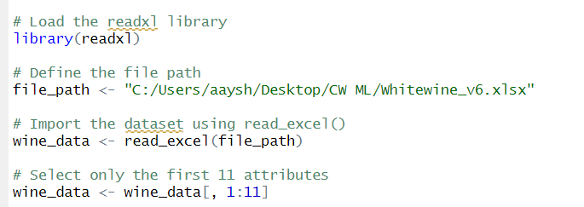

This line of code imports the data from the Excel file into R and stores it in a data frame called **wine_data**, preparing it for further analysis and manipulation.

The `wine_data <- wine_data[, 1:11]` line in R keeps only the first 11 columns of `wine_data`, focusing on key attributes. Running `dim(wine_data) ` after this will show the dataset now has 11 columns but retains its original row count, offering a snapshot of its new, streamlined structure. For example, if it started with 2700 rows, it now displays as 2700 rows by 11 columns.

**Detection/Removal Outliers**

The first step of the machine learning project involves gathering data, which has already been provided for this project. The second step is data pre-processing, which involves performing several tasks before conducting k-means. These tasks include scaling, as well as detecting and removing outliers.

To ensure the reliability and accuracy of our dataset for further analysis, we perform outlier detection and removal. Outliers, as extreme and atypical observations, can distort visualizations, skew statistical analyses, and negatively impact predictive models. By systematically identifying and eliminating outliers from each attribute, we aim to enhance data representation accuracy, improve statistical analysis robustness, and facilitate more effective modelling. This process helps us gain more accurate insights into the underlying patterns and relationships within the data, ultimately leading to better decision-making and more reliable conclusions in our analyses.

This code segment conducts outlier removal and visualization for a dataset named `wine_data`, focusing on white wine varieties and their chemical properties. It first generates boxplots for each attribute to visualize the data distribution before outlier removal. Then, it defines a function to remove outliers using the interquartile range method. Outliers are removed from each attribute, resulting in a cleaned dataset named `clean_data`. The code then plots boxplots again to visualize the cleaned data distribution. Finally, the cleaned data is consolidated into a data frame named `clean_df`. Overall, this code provides a clear before-and-after comparison of data distribution, aiding in understanding the impact of outlier removal on the dataset's characteristics.

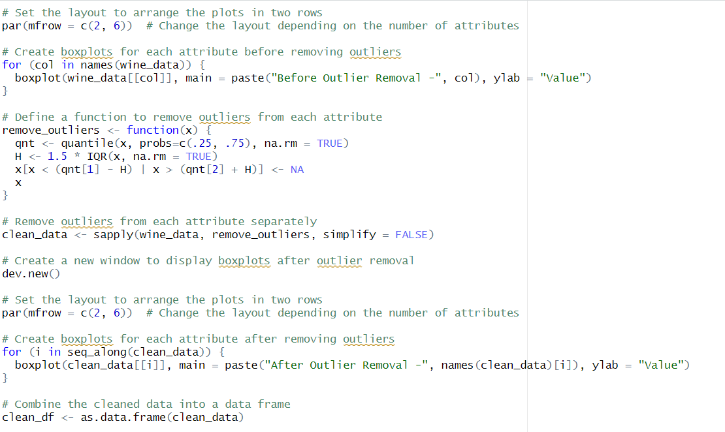

By executing a specific set of codes, it is possible to exclude the outliers from our dataset.

This exclusion results in a new dataset, renamed "**clean_data**". After removing the outliers, a boxplot of the dataset is presented below for further analysis.

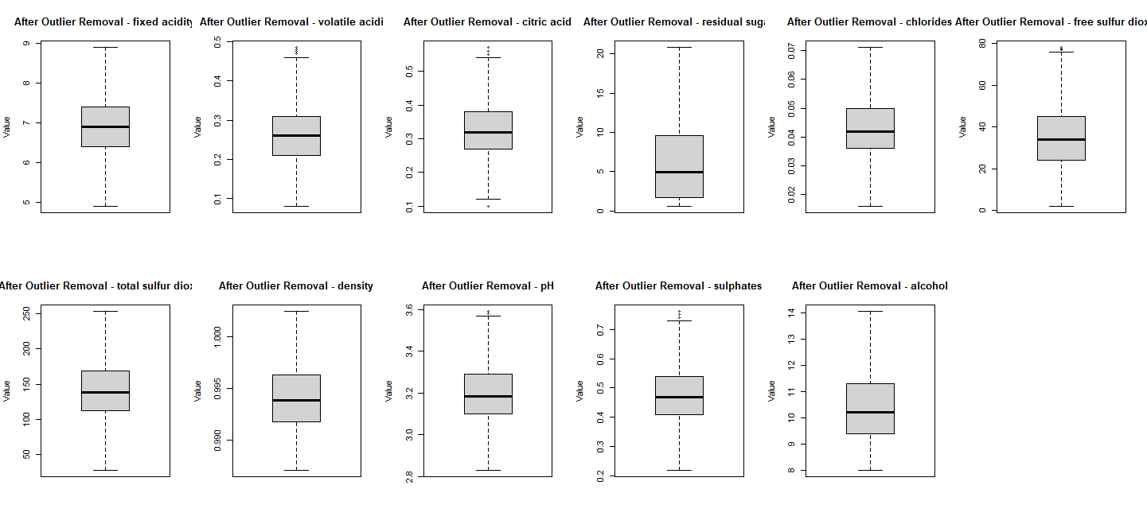

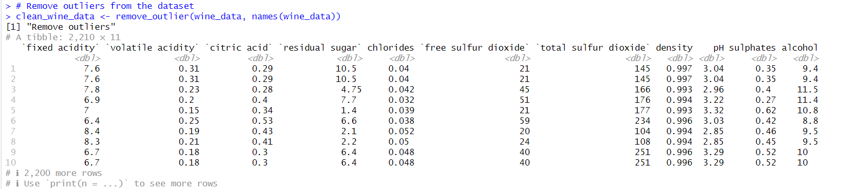

**Data Normalization**

Then, the z-score method is used to do the scaling function. One of the most popular and efficient methods for scaling data is the z-score scaling approach, which is frequently regarded as the best method for several reasons.

One factor is the z-score scaling method's foundation in the data's mean and standard deviation. These common statistical techniques can help make the data easier to understand and compare across many datasets. The z-score scaling method also has the benefit of being resistant to outliers. Other scaling techniques, such as min-max scaling, which is dependent on the data range, might be significantly impacted by outliers.

The z-score method, on the other hand, is based on the mean and standard deviation, which are less susceptible to outliers and can aid in normalising the data even when there are outliers. Since the z-score scaling approach is also a linear transformation, the data distribution remains unaffected. This is crucial because it maintains the connections between the data points and can support preserving the data's statistical features.



**Usage of Automation Tools to find the optimal number of clusters.**

Four automated tools (NBclust, Elbow, Gap statistics, and Silhouette) are integrated into the code to determine the number of cluster centres.

1. NBclust tool.

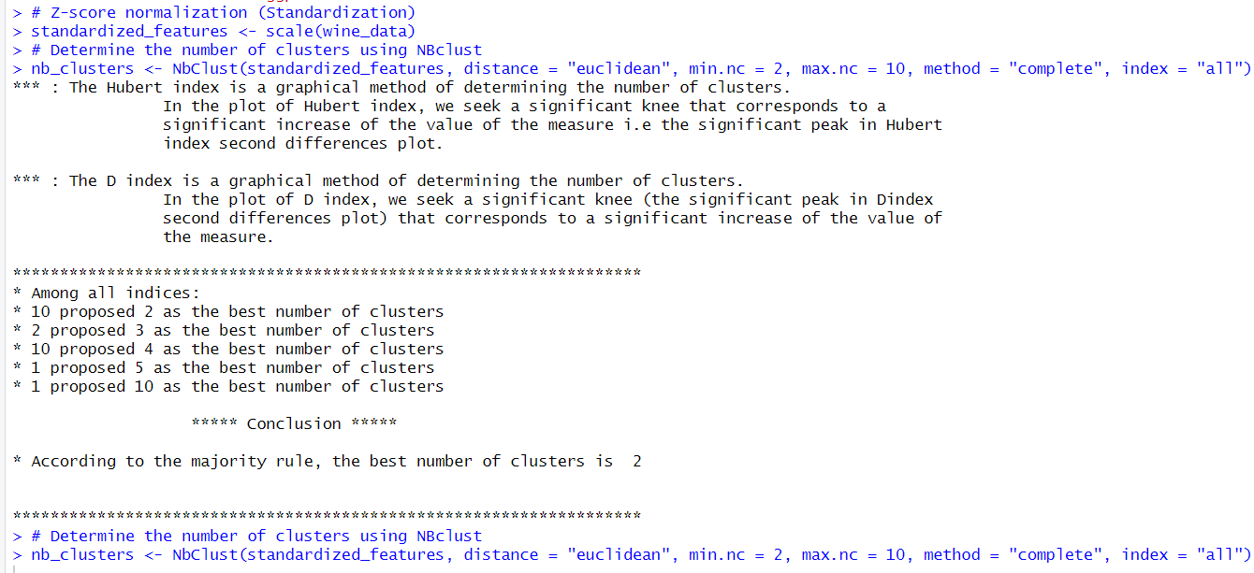

The plotted diagram:

Through the NBclust tool techniques, mostly 3 clusters are favourably predicted as the best number of clusters. As it is clearly printed above in the section where they are determining according to the majority rule.

**NB Clust output:**

> # Determine the number of clusters using NBclust

> nb_clusters <- NbClust(standardized_features, distance = "euclidean", min.nc = 2, max.nc = 10, method = "complete", index = "all")

*** : The Hubert index is a graphical method of determining the number of clusters.

In the plot of Hubert index, we seek a significant knee that corresponds to a

significant increase of the value of the measure i.e the significant peak in Hubert

index second differences plot.

*** : The D index is a graphical method of determining the number of clusters.

In the plot of D index, we seek a significant knee (the significant peak in Dindex

second differences plot) that corresponds to a significant increase of the value of

the measure.

*******************************************************************

* Among all indices:

* 10 proposed 2 as the best number of clusters

* 2 proposed 3 as the best number of clusters

* 10 proposed 4 as the best number of clusters

* 1 proposed 5 as the best number of clusters

* 1 proposed 10 as the best number of clusters

***** Conclusion *****

* According to the majority rule, the best number of clusters is 2

*******************************************************************

> print(nb_clusters)

$All.index

KL CH Hartigan CCC Scott Marriot TrCovW TraceW Friedman Rubin Cindex DB Silhouette Duda

2 3.6572 12.3793 118.3443 -54.7743 153.9936 7.472929e+35 11479485 29553.40 0.0859 1.0046 0.3034 0.2841 0.6293 0.9580

3 0.2377 65.6090 560.3503 -68.1995 1861.4052 8.933806e+35 10926677 28311.55 1.2103 1.0487 0.3241 0.7130 0.4827 0.8262

4 5.2290 239.5215 35.2567 -44.9081 4172.9953 6.746759e+35 6067522 23441.22 32.6935 1.2665 0.3460 1.3591 0.1765 0.9665

5 9.7655 190.7338 98.6165 -55.9322 4469.3137 9.446098e+35 5905375 23138.62 33.0095 1.2831 0.3659 1.5983 0.1338 0.9421

6 0.1413 177.8278 132.4541 -60.0279 5352.6012 9.807048e+35 5449178 22321.81 33.7170 1.3300 0.3670 1.7234 0.1209 0.8744

7 2.0095 177.4856 38.7639 -59.7358 6641.8783 8.280412e+35 4918834 21275.76 38.1718 1.3954 0.3841 1.8880 0.1270 0.7780

8 0.6552 159.7987 100.6276 -65.7870 6907.5014 9.801903e+35 4723240 20973.86 39.0168 1.4155 0.3877 1.8455 0.1123 0.5263

9 1.0873 157.5704 13.7366 -65.5261 8443.5024 7.023442e+35 4433410 20218.10 41.0982 1.4684 0.3984 1.7967 0.0984 0.9914

10 1.2047 142.2509 15.6533 -73.6633 8559.4107 8.306558e+35 4384045 20115.42 41.3958 1.4759 0.4215 1.7564 0.0960 0.7154

Pseudot2 Beale Ratkowsky Ball Ptbiserial Frey McClain Dunn Hubert SDindex Dindex SDbw

2 118.3004 0.3265 0.0230 14776.700 0.1431 46.1853 0.0003 0.5539 3e-04 0.7280 3.1459 0.4979

3 562.3675 1.5658 0.0672 9437.183 0.3988 8.5337 0.0094 0.1376 3e-04 1.1105 3.1047 0.7624

4 33.7028 0.2576 0.2038 5860.304 0.3698 0.7609 0.7068 0.0842 1e-04 1.5661 2.8004 0.7514

5 104.3281 0.4572 0.1883 4627.725 0.3715 -0.0097 0.7432 0.0894 1e-04 1.7107 2.7849 0.7511

6 132.4636 1.0685 0.1899 3720.302 0.4112 -0.1685 0.8797 0.0924 1e-04 1.8238 2.7442 0.8062

7 31.9562 2.1055 0.1896 3039.395 0.4467 -0.1633 0.9540 0.0992 1e-04 2.0880 2.6899 0.9018

8 108.8899 6.6452 0.1823 2621.732 0.4478 -0.3710 0.9563 0.1002 1e-04 2.1101 2.6748 0.8988

9 13.7473 0.0646 0.1787 2246.456 0.4504 -0.2289 0.9582 0.1031 1e-04 1.9627 2.6309 0.7761

10 19.4961 2.9031 0.1708 2011.542 0.4541 -0.1386 0.9638 0.1093 1e-04 1.9532 2.6256 0.7484

$All.CriticalValues

CritValue_Duda CritValue_PseudoT2 Fvalue_Beale

2 0.9168 244.6022 0.9804

3 0.9167 242.7853 0.1015

4 0.9001 108.0296 0.9927

5 0.9103 167.3714 0.9297

6 0.8989 103.6721 0.3826

7 0.8191 24.7307 0.0175

8 0.8237 25.8957 0.0000

9 0.9091 158.2874 1.0000

10 0.7582 15.6239 0.0010

$Best.nc

KL CH Hartigan CCC Scott Marriot TrCovW TraceW Friedman Rubin Cindex DB

Number_clusters 5.0000 4.0000 4.0000 4.0000 4.00 4.000000e+00 4 4.000 4.0000 4.0000 2.0000 2.0000

Value_Index 9.7655 239.5215 525.0937 -44.9081 2311.59 4.886387e+35 4859155 4567.742 31.4832 -0.2013 0.3034 0.2841

Silhouette Duda PseudoT2 Beale Ratkowsky Ball PtBiserial Frey McClain Dunn Hubert SDindex Dindex

Number_clusters 2.0000 2.000 2.0000 2.0000 4.0000 3.000 10.0000 3.0000 2e+00 2.0000 0 2.000 0

Value_Index 0.6293 0.958 118.3004 0.3265 0.2038 5339.517 0.4541 8.5337 3e-04 0.5539 0 0.728 0

SDbw

Number_clusters 2.0000

Value_Index 0.4979

$Best.partition

[1] 1 1 1 1 1 1 1 1 1 1 1 1 1 1 1 1 1 1 1 1 1 1 1 1 1 1 1 1 1 1 1 1 1 1 1 1 1 1 1 1 1 1 1 1 1 1 1 1 1 1 1 1 1 1 1 1 1 1 1 1 1

[62] 1 1 1 1 1 1 1 1 1 1 1 1 1 1 1 1 1 1 1 1 1 1 1 1 1 1 1 1 1 1 1 1 1 1 1 1 1 1 1 1 1 1 1 1 1 1 1 1 1 1 1 1 1 1 1 1 1 1 1 1 1

[123] 1 1 1 1 1 1 1 1 1 1 1 1 1 1 1 1 1 1 1 1 1 1 1 1 1 1 1 1 1 1 1 1 1 1 1 1 1 1 1 1 1 1 1 1 1 1 1 1 1 1 1 1 1 1 1 1 1 1 1 1 1

[184] 1 1 1 1 1 1 1 1 1 1 1 1 1 1 1 1 1 1 1 1 1 1 1 1 1 1 1 1 1 1 1 1 1 1 1 1 1 1 1 1 1 1 1 1 1 1 1 1 1 1 1 1 1 1 1 1 1 1 1 1 1

[245] 1 1 1 1 1 1 1 1 1 1 1 1 1 1 1 1 1 1 1 1 1 1 1 1 1 1 1 1 1 1 1 1 1 1 1 1 1 1 1 1 1 1 1 1 1 1 1 1 1 1 1 1 1 1 1 1 1 1 1 1 1

[306] 1 1 1 1 1 1 1 1 1 1 1 1 1 1 1 1 1 1 1 1 1 1 1 1 1 1 1 1 1 1 1 1 1 1 1 1 1 1 1 1 1 1 1 1 1 1 1 1 1 1 1 1 1 1 1 1 1 1 1 1 1

[367] 1 1 1 1 1 1 1 1 1 1 1 1 1 1 1 1 1 1 1 1 1 1 1 1 1 1 1 1 1 1 1 1 1 1 1 1 1 1 1 1 1 1 1 1 1 1 1 1 1 1 1 1 1 1 1 1 1 1 1 1 1

[428] 1 1 1 1 1 1 1 1 1 1 1 1 1 1 1 1 1 1 1 1 1 1 1 1 1 1 1 1 1 1 1 1 1 1 1 1 1 1 1 1 1 1 1 1 1 1 1 1 1 1 1 1 1 1 1 1 1 1 1 1 1

[489] 1 1 1 1 1 1 1 1 1 1 1 1 1 1 1 1 1 1 1 1 1 1 1 1 1 1 1 1 1 1 1 1 1 1 1 1 1 1 1 1 1 1 1 1 1 1 1 1 1 1 1 1 1 1 1 1 1 1 1 1 1

[550] 1 1 1 1 1 1 1 1 1 1 1 1 1 1 1 1 1 1 1 1 1 1 1 1 1 1 1 1 1 1 1 1 1 1 1 1 1 1 1 1 1 1 1 1 1 1 1 1 1 1 1 1 1 1 1 1 1 1 1 1 1

[611] 1 1 1 1 1 1 1 1 1 1 1 1 1 1 1 1 1 1 1 1 1 1 1 1 1 1 1 1 1 1 1 1 1 1 1 1 1 1 1 1 1 1 1 1 1 1 1 1 1 1 1 1 1 1 1 1 1 1 1 1 1

[672] 1 1 1 1 1 1 1 1 1 1 1 1 1 1 1 1 1 1 1 1 1 1 1 1 1 1 1 1 1 1 1 1 1 1 1 1 1 1 1 1 1 1 1 1 1 1 1 1 1 1 1 1 1 1 1 1 1 1 1 1 1

[733] 1 1 1 1 1 1 1 1 1 1 1 1 1 1 1 1 1 1 1 1 1 1 1 1 1 1 1 1 1 1 1 1 1 1 1 1 1 1 1 1 1 1 1 1 1 1 1 1 1 1 1 1 1 1 1 1 1 1 1 1 1

[794] 1 1 1 1 1 1 1 1 1 1 1 1 1 1 1 1 1 1 1 1 1 1 1 1 1 1 1 1 1 1 1 1 1 1 1 1 1 1 1 1 1 1 1 1 1 1 1 1 1 1 1 1 1 1 1 1 1 1 1 1 1

[855] 1 1 1 1 1 1 1 1 1 1 1 1 1 1 1 1 1 1 1 1 1 1 1 1 1 1 1 1 1 1 1 1 1 1 1 1 1 1 1 1 1 1 1 1 1 1 1 1 1 1 1 1 1 1 1 1 1 1 1 1 1

[916] 1 1 1 1 1 1 1 1 1 1 1 1 1 1 1 1 1 1 1 1 1 1 1 1 1 1 1 1 1 1 1 1 1 1 1 1 1 1 1 1 1 1 1 1 1 1 1 1 1 1 1 1 1 1 1 1 1 1 1 1 1

[977] 1 1 1 1 1 1 1 1 1 1 1 1 1 1 1 1 1 1 1 1 1 1 1 1

[ reached getOption("max.print") -- omitted 1700 entries ]

Based on the majority rule applied to the output from NBclust, the best number of clusters is determined to be 2. This decision is made by considering the number of indices favouring each cluster number. In this case:

- 10 indices proposed 2 as the best number of clusters.

- 2 indices proposed 3 as the best number of clusters.

- 10 indices proposed 4 as the best number of clusters.

- 1 index proposed 5 as the best number of clusters.

- 1 index proposed 10 as the best number of clusters.

Since 10 indices favoured 2 clusters, the highest among all options, it is determined as the best number of clusters according to the majority rule. Therefore, you should proceed with 2 clusters based on this analysis.

1. A graph with a line

   Description automatically generatedElbow Method.

The elbow method plot is a useful tool for determining the optimal number of clusters in K-means clustering . This plot shows the Within-Cluster Sum of Squares (WCSS) for different numbers of clusters. The WCSS is calculated as the sum of the squared distances between each point in a cluster and the centre of that cluster. The optimal number of clusters is usually identified by finding the "elbow" of the graph, where the curve starts to level off. In this particular case, the optimal number of clusters is 2.

1. 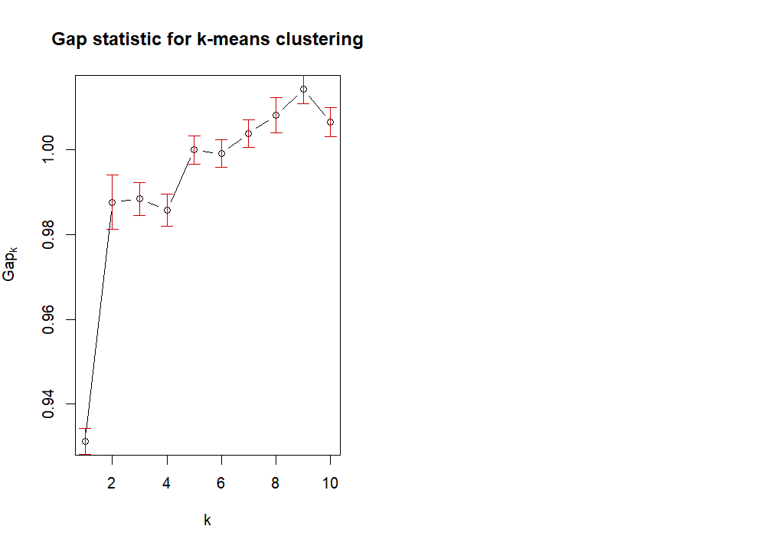Cluster Gap

|  |
| --- |
| # Compute gap statistics with increased number of bootstrap replicates  > gap <- clusGap(standardized_features, FUN = function(x, k) kmeans(x, k, iter.max = 100), K.max = 10, B = 100)  Clustering k = 1,2,..., K.max (= 10): .. done  Bootstrapping, b = 1,2,..., B (= 100) [one "." per sample]:  .................................................. 50  .................................................. 100  >  > # Plot the gap statistics  > plot(gap, main = "Gap statistic for k-means clustering")  >  > # Determine the optimal number of clusters using maxSE function  > best_clusters <- maxSE(gap$Tab[, "gap"], gap$Tab[, "SE.sim"], method = "Tibs2001SEmax")  >  > # Check contents of best_clusters list  > str(best_clusters)  int 2 |
|  |
| |  | | --- | | Based on the gap statistic analysis for k-means clustering, it is clear that the optimal number of clusters is 2.  This observation coincides with the peak in the gap statistic curve, which indicates the maximum separation between clusters.  As a result, we suggest dividing the data into two clusters based on this insight.  Further exploration of these clusters could reveal significant patterns within the dataset. | |

1. 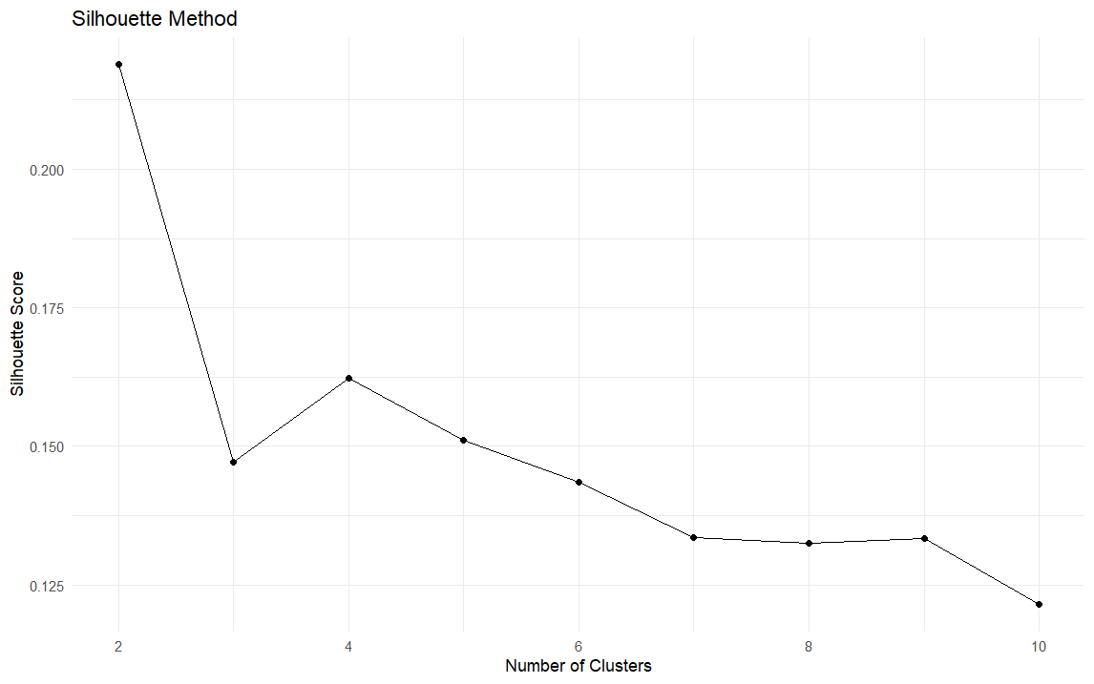Silhouette Method

The image shows a line graph for determining the optimal number of clusters in unsupervised machine learning using silhouette scores, which range from -1 to 1 indicating how well data points fit within a cluster. The graph's x-axis represents the number of clusters, and the y-axis shows silhouette scores. A peak in the graph suggests the best cluster number. However, the graph lacks a clear maximum, implying either the data doesn't fit well into up to 10 clusters or the best cluster number might be around 4 or 5, though this is not strongly indicated.

**K-means clustering**

The next step involves performing a k-means clustering analysis using all the input variables from the dataset. To determine the most effective number of clusters (k), automated methods such as the Elbow Method, the Silhouette Method, and the Gap Statistic are employed. Each method evaluates the dataset differently to suggest the optimal k value that best represents the data's structure.

After applying these methods, the one that provides the most coherent and interpretable outcome will be selected to define the number of clusters for the k-means analysis. This approach ensures the analysis is grounded in a methodologically sound selection of k, leading to more meaningful and actionable insights from the clustering process.

**K = 2**

|  |
| --- |
| # Add k=2  > k <- 2  > set.seed(123) # Set the seed for reproducibility  > km <- kmeans(standardized_features, centers = k, nstart = 25)  > fviz_cluster(km, data = standardized_features)  > print(km)  K-means clustering with 2 clusters of sizes 1615, 1085  Cluster means:  fixed acidity volatile acidity citric acid residual sugar chlorides free sulfur dioxide  1 -0.1399463 -0.07052877 -0.1332093 -0.5941660 -0.2719014 -0.3987123  2 0.2083072 0.10498062 0.1982793 0.8844038 0.4047196 0.5934749  total sulfur dioxide density pH sulphates alcohol  1 -0.5190249 -0.6522277 0.1625998 -0.02850696 0.5279349  2 0.7725578 0.9708274 -0.2420265 0.04243202 -0.7858202  Clustering vector:  [1] 2 1 2 1 2 2 1 1 2 2 1 2 1 2 1 1 1 2 2 1 2 2 1 1 1 2 1 1 1 1 1 1 1 1 1 2 2 2 2 2 1 1 1 2 2 1 1 1 1  [50] 2 2 1 2 1 1 1 1 1 1 1 1 2 2 1 1 1 1 2 1 2 2 1 2 2 2 2 2 2 1 1 1 2 2 1 1 1 2 2 1 2 1 2 1 1 2 2 1 2  [99] 2 2 1 2 2 2 2 2 2 2 2 1 1 2 2 1 1 1 2 2 1 1 2 2 1 2 2 2 2 2 1 2 2 1 2 1 2 1 1 1 2 1 2 1 1 2 1 2 2  [148] 1 2 2 2 2 1 1 1 2 2 2 1 2 2 2 2 1 1 2 2 1 2 2 2 2 2 1 1 1 2 2 2 2 1 1 1 2 2 2 1 2 2 2 2 2 2 2 2 2  [197] 2 2 1 1 1 2 1 2 2 2 2 2 2 1 1 1 1 1 1 1 1 2 2 1 2 1 2 1 1 1 1 1 1 1 2 2 2 2 2 1 1 2 2 1 2 1 1 1 1  [246] 1 2 2 1 1 1 1 2 1 2 2 1 2 2 2 1 2 1 2 2 1 1 1 2 2 2 2 1 2 1 2 2 2 2 2 2 1 1 2 2 1 2 2 2 2 2 2 2 2  [295] 2 1 1 1 2 1 2 2 2 2 1 2 1 2 2 2 1 1 2 1 1 1 2 2 1 1 2 2 2 2 2 2 2 2 2 1 2 2 2 2 2 1 2 2 2 2 2 2 2  [344] 2 2 2 2 1 2 2 2 2 2 1 2 2 2 2 1 2 2 2 2 2 1 2 2 1 2 2 1 2 2 1 2 2 2 2 2 2 2 2 2 2 1 2 1 2 2 2 2 2  [393] 2 2 2 2 2 2 2 2 2 2 2 2 2 2 2 1 1 1 2 2 1 2 1 1 2 2 2 1 1 2 2 2 2 2 1 2 2 1 2 2 2 1 2 2 2 1 2 1 2  [442] 2 1 2 1 2 1 1 1 2 1 2 2 2 1 2 1 2 2 2 2 2 2 1 2 2 1 2 1 2 2 2 2 2 2 1 1 1 2 1 2 2 2 2 2 1 1 2 1 2  [491] 2 2 2 2 2 1 2 2 2 2 2 2 1 2 2 1 2 1 2 1 1 1 1 2 2 2 2 2 2 2 2 2 2 2 2 1 1 1 2 2 1 2 2 2 1 1 1 2 2  [540] 1 1 1 2 2 1 1 1 1 2 1 2 2 1 2 2 2 2 2 2 2 1 2 1 1 2 1 2 1 1 1 1 1 1 2 1 1 1 1 2 1 2 1 1 2 1 2 2 1  [589] 1 1 2 2 2 2 2 2 1 1 1 2 1 1 2 1 1 2 1 1 1 1 2 1 2 1 1 2 2 1 1 1 1 1 2 1 2 1 1 1 1 1 1 1 1 1 1 2 1  [638] 1 2 1 2 1 2 2 2 2 1 1 2 1 1 1 1 2 2 2 2 2 1 1 2 2 2 2 1 2 2 2 1 1 2 2 1 1 2 2 1 2 2 1 2 2 2 2 2 2  [687] 2 1 1 1 2 1 1 2 2 2 2 2 1 2 1 2 1 1 1 2 2 1 2 2 1 2 2 1 1 2 2 1 2 2 1 1 1 1 2 2 1 2 1 1 1 1 1 1 1  [736] 1 2 2 2 2 1 2 1 2 2 2 2 2 2 2 1 2 1 1 1 1 1 2 1 1 1 1 2 2 1 2 1 1 1 2 1 2 1 2 2 1 2 2 2 2 2 2 1 2  [785] 1 1 1 1 1 1 2 2 1 1 1 1 2 2 2 2 2 1 1 2 1 2 2 1 1 2 2 2 1 1 1 1 1 2 1 1 2 1 1 1 2 2 1 1 1 2 2 2 1  [834] 1 1 1 1 2 2 1 2 1 1 1 2 2 1 1 2 1 1 2 2 2 2 1 2 2 2 2 2 2 1 1 1 2 2 2 1 1 1 2 2 1 2 2 2 2 2 2 2 1  [883] 2 2 2 1 1 1 1 2 2 2 2 2 1 2 2 2 1 2 2 2 1 2 2 2 2 2 1 2 2 2 2 1 1 2 1 2 2 2 2 1 1 2 2 1 1 2 1 1 1  [932] 1 1 2 1 2 1 2 1 1 1 1 2 2 2 1 1 2 1 1 2 1 2 2 1 1 2 2 1 1 2 1 1 2 2 2 2 2 2 2 2 2 2 2 2 2 2 1 1 1  [981] 1 1 1 1 1 1 1 1 1 1 1 2 1 1 2 2 2 2 1 1  [ reached getOption("max.print") -- omitted 1700 entries ]  Within cluster sum of squares by cluster:  [1] 13054.25 10088.00  (between_SS / total_SS = 22.1 %)  Available components:  [1] "cluster" "centers" "totss" "withinss" "tot.withinss" "betweenss"  [7] "size" "iter" "ifault" |
|  |
| |  | | --- | | > | |

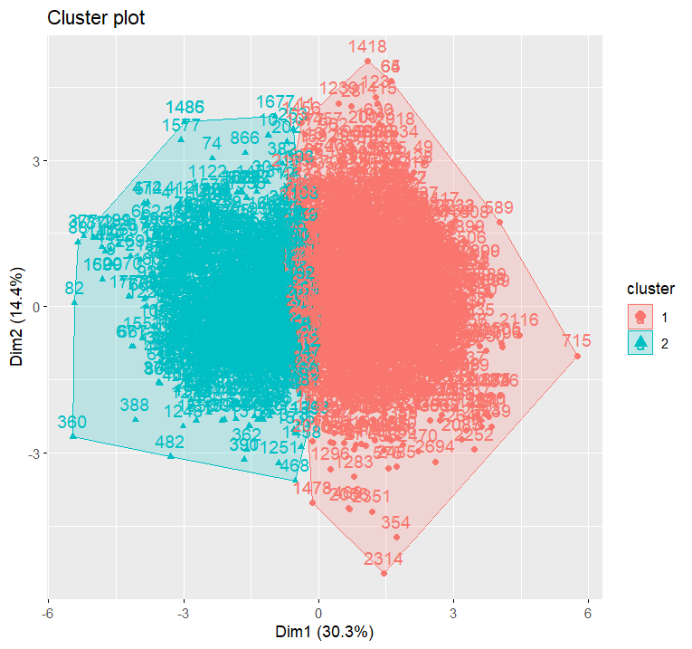

|  |
| --- |
| # Display the BSS/TSS ratio  > BSS <- sum(km$betweenss)  > TSS <- sum(km$totss)  > BSS_TSS_ratio <- BSS/TSS  > cat("The ratio of between_cluster_sums_of_squares (BSS) over total_sum_of_squares (TSS) is", BSS_TSS_ratio, "\n")  The ratio of between_cluster_sums_of_squares (BSS) over total_sum_of_squares (TSS) is 0.220511  >  > # Display the BSS and WSS indices  > cat("The between_cluster_sums_of_squares (BSS) index is", BSS, "\n")  The between_cluster_sums_of_squares (BSS) index is 6546.752  > cat("The within_cluster_sums_of_squares (WSS) index is", km$tot.withinss, "\n")  The within_cluster_sums_of_squares (WSS) index is 23142.25  >  > # Plot the WSS for k = 2  > fviz_nbclust(standardized_features, kmeans, method = "wss") +  + ggtitle("WSS Plot") +  + xlab("Number of clusters") +  + ylab("Within-cluster sum of squares") |
|  |
| |  | | --- | | > | |

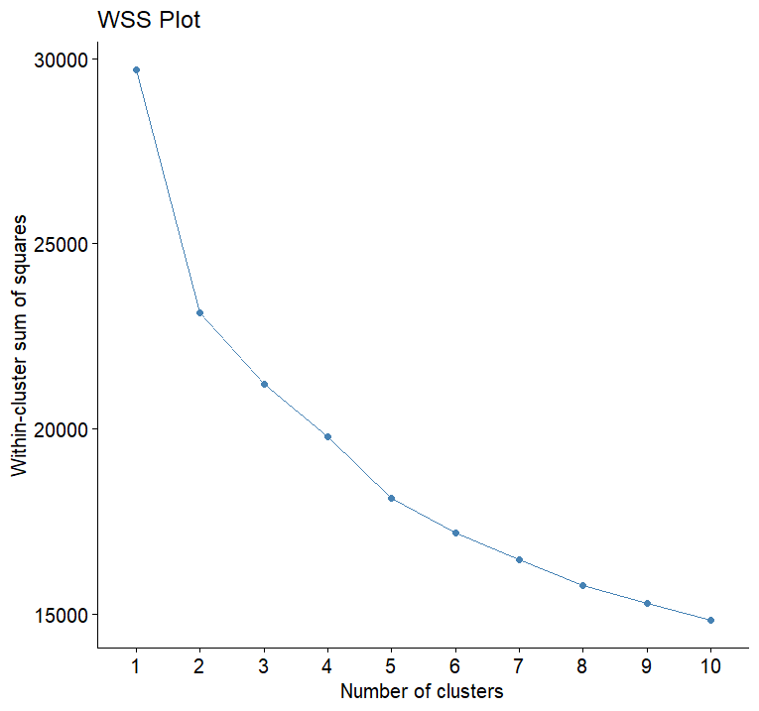

**K = 3**

|  |
| --- |
| > # Add k=3  > k <- 3  > set.seed(123) # Set the seed for reproducibility  > km <- kmeans(standardized_features, centers = k, nstart = 25)  > fviz_cluster(km, data = standardized_features)  > print(km)  K-means clustering with 3 clusters of sizes 881, 1019, 800  Cluster means:  fixed acidity volatile acidity citric acid residual sugar  1 -0.7777076 -0.115166257 -0.3562205 -0.6152924  2 0.1580391 0.103222127 0.1985254 0.9551923  3 0.6551482 -0.004652344 0.1394161 -0.5390855  chlorides free sulfur dioxide total sulfur dioxide density  1 -0.2931828 -0.2069455 -0.4116902 -0.6828114  2 0.4135009 0.6338607 0.8010510 1.0148477  3 -0.2038293 -0.5794813 -0.5669650 -0.5407162  pH sulphates alcohol  1 0.8087160 0.25043639 0.5283395  2 -0.2445912 0.04231209 -0.8147122  3 -0.5790504 -0.32968809 0.4559058  Clustering vector:  [1] 2 3 2 3 2 2 3 3 2 3 3 3 1 2 1 3 3 2 2 3 2 2 3 3 3 2 1 3 1  [30] 3 1 3 1 1 3 2 2 2 2 2 3 3 3 2 2 1 3 3 3 2 2 3 2 1 3 3 3 3  [59] 3 3 1 2 2 3 3 3 3 2 3 2 2 3 2 2 2 2 3 2 1 1 1 2 3 3 3 1 3  [88] 2 3 3 1 2 3 1 2 2 3 2 2 2 1 2 2 2 2 2 2 2 2 3 1 2 2 1 1 3  [117] 2 2 3 3 2 2 3 2 2 2 2 2 1 2 2 3 3 1 2 1 1 3 2 3 2 3 3 2 1  [146] 2 2 1 2 2 2 2 3 3 3 2 2 2 3 2 2 2 2 1 3 2 2 3 2 2 2 2 2 3  [175] 3 1 2 2 2 2 1 3 3 2 2 2 3 2 2 2 2 2 2 2 2 2 2 2 3 3 3 3 3  [204] 2 2 2 2 2 2 1 1 1 1 1 1 3 3 2 2 3 2 3 2 3 3 3 1 3 1 3 2 2  [233] 2 2 2 3 3 2 2 1 2 1 1 3 3 3 2 2 1 1 1 3 3 3 2 2 1 2 2 2 3  [262] 2 1 2 2 1 1 3 2 2 2 2 1 2 3 2 2 2 2 2 2 1 1 2 2 1 2 2 2 2  [291] 2 2 2 2 2 3 3 3 2 3 2 2 1 2 3 2 3 2 2 2 3 3 2 3 3 3 2 2 1  [320] 3 2 2 2 2 2 2 2 2 2 3 2 2 2 2 3 1 2 2 2 2 2 2 2 2 2 2 2 1  [349] 2 3 2 3 2 1 2 2 2 3 3 2 2 2 2 2 1 2 2 3 2 2 3 2 1 3 2 2 2  [378] 2 2 1 2 3 2 2 3 2 1 2 2 2 2 2 2 2 2 2 2 2 2 2 2 2 2 2 2 2  [407] 2 3 3 1 2 2 1 3 3 1 2 2 2 1 3 2 2 2 2 2 3 2 2 3 2 2 2 1 2  [436] 3 2 1 2 1 3 2 3 2 3 2 1 1 1 2 1 2 2 2 3 2 3 2 2 2 2 2 2 1  [465] 2 2 1 1 1 2 2 2 2 2 2 3 3 1 2 3 2 2 2 2 2 3 3 2 3 2 2 2 2  [494] 2 2 1 2 2 2 2 2 2 3 2 2 3 2 1 1 3 3 3 1 2 2 2 2 2 2 2 2 2  [523] 2 2 2 3 3 3 2 2 1 2 2 2 3 1 1 2 2 3 3 3 2 2 3 3 3 1 2 1 2  [552] 2 3 2 2 3 2 2 2 2 1 2 1 1 2 3 2 1 1 1 1 3 1 2 1 3 3 3 2 3  [581] 2 1 1 2 3 2 2 3 3 1 2 2 2 2 2 2 1 1 3 2 3 1 2 3 3 2 3 3 3  [610] 1 2 3 2 1 1 2 2 1 1 3 1 1 2 1 2 1 1 3 1 3 3 3 3 3 1 2 3 1  [639] 2 3 2 3 2 2 2 2 3 1 2 1 1 3 1 2 2 2 2 2 3 3 2 2 2 2 3 2 2  [668] 2 1 3 2 3 1 1 2 2 1 2 2 3 2 2 2 2 2 2 2 1 3 3 2 3 1 2 2 2  [697] 2 2 3 2 3 2 3 3 1 2 3 1 2 3 3 2 2 1 1 2 2 3 2 2 3 3 3 3 2  [726] 2 3 2 1 1 1 1 1 1 3 3 2 2 2 2 1 2 3 2 2 2 2 2 2 2 1 2 3 1  [755] 3 3 3 2 3 3 3 1 2 2 3 2 1 3 3 2 1 2 1 2 2 3 2 2 2 2 2 2 3  [784] 2 3 3 1 3 1 3 2 2 3 3 3 3 2 2 2 2 2 1 1 2 1 2 2 1 3 2 2 2  [813] 3 3 3 3 1 2 1 3 2 1 3 3 2 2 3 3 3 1 2 2 1 1 1 1 1 2 2 3 2  [842] 1 3 3 2 2 1 3 2 1 1 2 2 2 2 1 2 2 2 2 2 2 3 3 1 2 2 2 3 3  [871] 3 2 2 1 2 2 2 2 2 2 2 3 2 2 2 3 1 1 3 2 2 2 2 2 3 2 2 2 3  [900] 2 2 2 3 2 2 2 2 2 1 2 2 2 2 3 1 2 3 2 2 2 2 1 3 2 2 3 1 2  [929] 1 3 1 3 1 2 1 2 3 2 3 3 1 3 2 2 2 1 1 2 1 1 2 3 2 2 3 3 2  [958] 2 3 3 2 3 1 2 2 2 2 2 2 2 2 2 2 2 2 2 2 1 3 3 3 1 1 3 3 3  [987] 3 3 3 1 3 2 3 3 2 2 2 2 3 3  [ reached getOption("max.print") -- omitted 1700 entries ]  Within cluster sum of squares by cluster:  [1] 6403.376 9114.738 5691.925  (between_SS / total_SS = 28.6 %)  Available components:  [1] "cluster" "centers" "totss" "withinss"  [5] "tot.withinss" "betweenss" "size" "iter"  [9] "ifault"  > # Display the BSS/TSS ratio  > BSS <- sum(km$betweenss)  > TSS <- sum(km$totss)  > BSS_TSS_ratio <- BSS/TSS  > cat("The ratio of between_cluster_sums_of_squares (BSS) over total_sum_of_squares (TSS) is", BSS_TSS_ratio, "\n")  The ratio of between_cluster_sums_of_squares (BSS) over total_sum_of_squares (TSS) is 0.2855927  >  > # Display the BSS and WSS indices  > cat("The between_cluster_sums_of_squares (BSS) index is", BSS, "\n")  The between_cluster_sums_of_squares (BSS) index is 8478.961  > cat("The within_cluster_sums_of_squares (WSS) index is", km$tot.withinss, "\n")  The within_cluster_sums_of_squares (WSS) index is 21210.04  >  > # Plot the WSS  > fviz_nbclust(standardized_features, kmeans, method = "wss") +  + ggtitle("WSS Plot") +  + xlab("Number of clusters") +  + ylab("Within-cluster sum of squares")  > # Add k=3  > k <- 3  > set.seed(123) # Set the seed for reproducibility  > km <- kmeans(standardized_features, centers = k, nstart = 25)  > fviz_cluster(km, data = standardized_features)  > print(km)  K-means clustering with 3 clusters of sizes 881, 1019, 800  Cluster means:  fixed acidity volatile acidity citric acid residual sugar chlorides free sulfur dioxide  1 -0.7777076 -0.115166257 -0.3562205 -0.6152924 -0.2931828 -0.2069455  2 0.1580391 0.103222127 0.1985254 0.9551923 0.4135009 0.6338607  3 0.6551482 -0.004652344 0.1394161 -0.5390855 -0.2038293 -0.5794813  total sulfur dioxide density pH sulphates alcohol  1 -0.4116902 -0.6828114 0.8087160 0.25043639 0.5283395  2 0.8010510 1.0148477 -0.2445912 0.04231209 -0.8147122  3 -0.5669650 -0.5407162 -0.5790504 -0.32968809 0.4559058  Clustering vector:  [1] 2 3 2 3 2 2 3 3 2 3 3 3 1 2 1 3 3 2 2 3 2 2 3 3 3 2 1 3 1 3 1 3 1 1 3 2 2 2 2 2 3 3 3 2 2 1 3 3 3  [50] 2 2 3 2 1 3 3 3 3 3 3 1 2 2 3 3 3 3 2 3 2 2 3 2 2 2 2 3 2 1 1 1 2 3 3 3 1 3 2 3 3 1 2 3 1 2 2 3 2  [99] 2 2 1 2 2 2 2 2 2 2 2 3 1 2 2 1 1 3 2 2 3 3 2 2 3 2 2 2 2 2 1 2 2 3 3 1 2 1 1 3 2 3 2 3 3 2 1 2 2  [148] 1 2 2 2 2 3 3 3 2 2 2 3 2 2 2 2 1 3 2 2 3 2 2 2 2 2 3 3 1 2 2 2 2 1 3 3 2 2 2 3 2 2 2 2 2 2 2 2 2  [197] 2 2 3 3 3 3 3 2 2 2 2 2 2 1 1 1 1 1 1 3 3 2 2 3 2 3 2 3 3 3 1 3 1 3 2 2 2 2 2 3 3 2 2 1 2 1 1 3 3  [246] 3 2 2 1 1 1 3 3 3 2 2 1 2 2 2 3 2 1 2 2 1 1 3 2 2 2 2 1 2 3 2 2 2 2 2 2 1 1 2 2 1 2 2 2 2 2 2 2 2  [295] 2 3 3 3 2 3 2 2 1 2 3 2 3 2 2 2 3 3 2 3 3 3 2 2 1 3 2 2 2 2 2 2 2 2 2 3 2 2 2 2 3 1 2 2 2 2 2 2 2  [344] 2 2 2 2 1 2 3 2 3 2 1 2 2 2 3 3 2 2 2 2 2 1 2 2 3 2 2 3 2 1 3 2 2 2 2 2 1 2 3 2 2 3 2 1 2 2 2 2 2  [393] 2 2 2 2 2 2 2 2 2 2 2 2 2 2 2 3 3 1 2 2 1 3 3 1 2 2 2 1 3 2 2 2 2 2 3 2 2 3 2 2 2 1 2 3 2 1 2 1 3  [442] 2 3 2 3 2 1 1 1 2 1 2 2 2 3 2 3 2 2 2 2 2 2 1 2 2 1 1 1 2 2 2 2 2 2 3 3 1 2 3 2 2 2 2 2 3 3 2 3 2  [491] 2 2 2 2 2 1 2 2 2 2 2 2 3 2 2 3 2 1 1 3 3 3 1 2 2 2 2 2 2 2 2 2 2 2 2 3 3 3 2 2 1 2 2 2 3 1 1 2 2  [540] 3 3 3 2 2 3 3 3 1 2 1 2 2 3 2 2 3 2 2 2 2 1 2 1 1 2 3 2 1 1 1 1 3 1 2 1 3 3 3 2 3 2 1 1 2 3 2 2 3  [589] 3 1 2 2 2 2 2 2 1 1 3 2 3 1 2 3 3 2 3 3 3 1 2 3 2 1 1 2 2 1 1 3 1 1 2 1 2 1 1 3 1 3 3 3 3 3 1 2 3  [638] 1 2 3 2 3 2 2 2 2 3 1 2 1 1 3 1 2 2 2 2 2 3 3 2 2 2 2 3 2 2 2 1 3 2 3 1 1 2 2 1 2 2 3 2 2 2 2 2 2  [687] 2 1 3 3 2 3 1 2 2 2 2 2 3 2 3 2 3 3 1 2 3 1 2 3 3 2 2 1 1 2 2 3 2 2 3 3 3 3 2 2 3 2 1 1 1 1 1 1 3  [736] 3 2 2 2 2 1 2 3 2 2 2 2 2 2 2 1 2 3 1 3 3 3 2 3 3 3 1 2 2 3 2 1 3 3 2 1 2 1 2 2 3 2 2 2 2 2 2 3 2  [785] 3 3 1 3 1 3 2 2 3 3 3 3 2 2 2 2 2 1 1 2 1 2 2 1 3 2 2 2 3 3 3 3 1 2 1 3 2 1 3 3 2 2 3 3 3 1 2 2 1  [834] 1 1 1 1 2 2 3 2 1 3 3 2 2 1 3 2 1 1 2 2 2 2 1 2 2 2 2 2 2 3 3 1 2 2 2 3 3 3 2 2 1 2 2 2 2 2 2 2 3  [883] 2 2 2 3 1 1 3 2 2 2 2 2 3 2 2 2 3 2 2 2 3 2 2 2 2 2 1 2 2 2 2 3 1 2 3 2 2 2 2 1 3 2 2 3 1 2 1 3 1  [932] 3 1 2 1 2 3 2 3 3 1 3 2 2 2 1 1 2 1 1 2 3 2 2 3 3 2 2 3 3 2 3 1 2 2 2 2 2 2 2 2 2 2 2 2 2 2 1 3 3  [981] 3 1 1 3 3 3 3 3 3 1 3 2 3 3 2 2 2 2 3 3  [ reached getOption("max.print") -- omitted 1700 entries ]  Within cluster sum of squares by cluster:  [1] 6403.376 9114.738 5691.925  (between_SS / total_SS = 28.6 %)  Available components:  [1] "cluster" "centers" "totss" "withinss" "tot.withinss" "betweenss"  [7] "size" "iter" "ifault" |
|  |
| |  | | --- | | # Display the BSS/TSS ratio  > BSS <- sum(km$betweenss)  > TSS <- sum(km$totss)  > BSS_TSS_ratio <- BSS/TSS  > cat("The ratio of between_cluster_sums_of_squares (BSS) over total_sum_of_squares (TSS) is", BSS_TSS_ratio, "\n")  The ratio of between_cluster_sums_of_squares (BSS) over total_sum_of_squares (TSS) is 0.2855927  >  > # Display the BSS and WSS indices  > cat("The between_cluster_sums_of_squares (BSS) index is", BSS, "\n")  The between_cluster_sums_of_squares (BSS) index is 8478.961  > cat("The within_cluster_sums_of_squares (WSS) index is", km$tot.withinss, "\n")  The within_cluster_sums_of_squares (WSS) index is 21210.04  >  > # Plot the WSS  > fviz_nbclust(standardized_features, kmeans, method = "wss") +  + ggtitle("WSS Plot") +  + xlab("Number of clusters") +  + ylab("Within-cluster sum of squares") | |

**K = 4**

> # Add k=4

> k <- 4

> set.seed(123) # Set the seed for reproducibility

> km <- kmeans(standardized_features, centers = k, nstart = 25)

> fviz_cluster(km, data = standardized_features)

> print(km)

K-means clustering with 4 clusters of sizes 798, 967, 880, 55

Cluster means:

fixed acidity volatile acidity citric acid residual sugar chlorides free sulfur dioxide total sulfur dioxide

1 0.6605643 0.000255662 0.1276565 -0.5406396 -0.2352937 -0.5751762 -0.55899067

2 0.1654316 0.083307128 0.1633114 1.0276079 0.1578381 0.6392218 0.82992885

3 -0.7685667 -0.122871956 -0.3576269 -0.6177972 -0.3017874 -0.1994406 -0.40743236

4 -0.1957083 0.497551095 0.9985393 -0.3382701 5.4674150 0.2976518 0.03770612

density pH sulphates alcohol

1 -0.5414788 -0.5777631 -0.32543302 0.4579895

2 1.0558841 -0.2261453 0.04722806 -0.8082136

3 -0.6800679 0.8128470 0.25968270 0.5252066

4 0.1730882 -0.6466893 -0.26354102 -0.8384526

Clustering vector:

[1] 2 1 4 1 2 2 1 1 2 1 1 1 3 2 3 1 1 2 2 1 2 2 1 1 1 4 3 1 3 1 3 1 3 3 1 2 2 2 2 2 1 1 1 2 2 3 1 1 1 2 2 1 2 3 1 1

[57] 1 1 1 1 3 2 2 1 1 1 1 2 1 2 2 1 2 2 2 2 1 2 3 3 3 2 2 1 1 3 1 4 1 1 3 2 1 3 2 2 1 4 4 2 3 2 2 2 2 2 2 2 2 1 3 4

[113] 4 3 3 1 4 2 1 1 2 2 1 2 2 2 2 2 3 2 2 1 1 3 2 3 1 1 2 1 2 1 1 2 3 2 4 3 2 2 2 2 1 1 1 2 2 2 1 2 2 2 2 3 1 2 2 1

[169] 2 2 2 2 2 1 1 3 2 2 2 2 3 1 1 2 2 2 1 2 2 2 2 2 2 2 2 2 2 2 1 1 1 1 1 2 2 2 2 2 2 3 3 3 3 3 3 1 1 4 4 4 2 1 2 1

[225] 1 1 3 1 3 1 2 2 2 2 2 1 1 2 2 3 2 3 3 1 1 1 2 2 3 3 3 1 1 1 2 2 3 2 2 2 1 2 3 2 2 3 3 1 2 2 2 2 3 2 1 2 2 2 2 2

[281] 2 3 3 2 2 3 2 2 2 2 2 2 2 2 2 1 1 1 2 1 2 2 3 4 1 2 1 2 2 2 1 1 2 1 1 1 2 2 3 1 2 2 2 2 2 2 2 2 2 1 2 2 2 2 1 3

[337] 4 2 2 2 2 4 4 2 2 2 2 3 2 1 2 1 2 3 2 2 2 1 1 2 2 2 2 2 3 4 2 1 2 4 1 2 3 1 2 4 2 2 2 3 2 1 2 2 1 2 3 2 2 2 2 2

[393] 2 2 2 2 4 2 2 2 2 2 2 2 2 2 2 1 1 3 2 2 3 1 1 3 2 2 2 3 1 2 2 2 2 2 1 2 2 1 2 2 2 3 2 1 2 3 2 3 1 2 1 2 1 2 3 3

[449] 3 2 3 2 2 2 1 2 1 2 2 2 2 2 2 3 2 2 3 3 3 2 2 2 2 2 2 1 1 3 2 1 2 2 2 2 2 1 1 2 1 2 2 2 2 2 2 3 2 2 2 2 2 2 1 2

[505] 2 1 2 3 3 1 1 1 3 2 2 2 2 2 2 2 2 2 2 2 2 1 1 1 4 2 3 2 2 2 1 3 3 4 2 1 1 1 2 2 1 1 1 3 2 3 2 2 1 2 2 1 2 2 2 2

[561] 3 2 3 3 2 1 2 3 3 3 3 1 3 4 3 1 1 1 2 1 2 3 3 2 1 4 4 1 1 3 2 2 2 2 2 2 3 3 1 2 1 3 2 1 1 2 1 1 1 3 2 1 2 3 3 2

[617] 2 3 3 1 3 3 2 3 2 3 3 1 3 1 1 1 1 1 3 2 1 3 2 1 2 1 2 2 2 2 1 3 2 3 3 1 3 2 2 2 2 2 1 1 2 2 2 2 1 2 2 2 3 1 2 1

[673] 3 3 2 2 3 2 2 1 2 2 2 2 2 2 2 4 1 1 2 1 3 2 2 2 2 2 1 2 1 4 1 1 3 2 1 3 2 1 1 2 2 3 3 2 2 1 2 2 1 1 1 1 2 4 1 2

[729] 3 3 3 3 3 3 1 1 2 2 2 2 3 2 1 2 2 2 2 2 2 2 3 2 1 3 1 1 1 2 1 1 1 3 2 2 1 2 3 1 1 2 3 2 3 2 2 1 2 2 2 2 2 2 1 2

[785] 1 1 3 1 3 1 2 2 1 1 1 1 2 2 2 4 2 3 3 2 3 2 2 3 1 2 2 2 1 1 1 1 3 2 3 1 2 3 1 1 2 2 1 1 1 3 2 2 2 3 3 3 3 2 2 1

[841] 2 3 1 1 2 2 3 1 2 3 3 2 2 2 2 3 2 2 2 2 2 2 1 1 3 4 2 2 1 1 1 2 2 3 2 2 2 2 2 2 2 1 2 2 2 1 3 3 1 2 2 2 2 2 1 2

[897] 2 2 1 2 4 2 1 2 2 2 2 2 3 2 2 2 2 1 3 2 1 2 2 2 2 3 1 2 2 1 3 2 3 1 3 1 3 2 3 2 1 2 1 1 3 1 4 4 2 3 3 2 3 3 4 1

[953] 2 2 1 1 2 2 1 1 2 1 3 2 2 2 2 2 2 2 2 2 2 2 2 2 2 3 1 1 1 3 3 1 1 1 1 1 1 3 1 2 1 1 2 2 2 2 1 1

[ reached getOption("max.print") -- omitted 1700 entries ]

Within cluster sum of squares by cluster:

[1] 5450.8405 7126.9939 6376.7017 577.2049

(between_SS / total_SS = 34.2 %)

Available components:

[1] "cluster" "centers" "totss" "withinss" "tot.withinss" "betweenss" "size"

[8] "iter" "ifault"

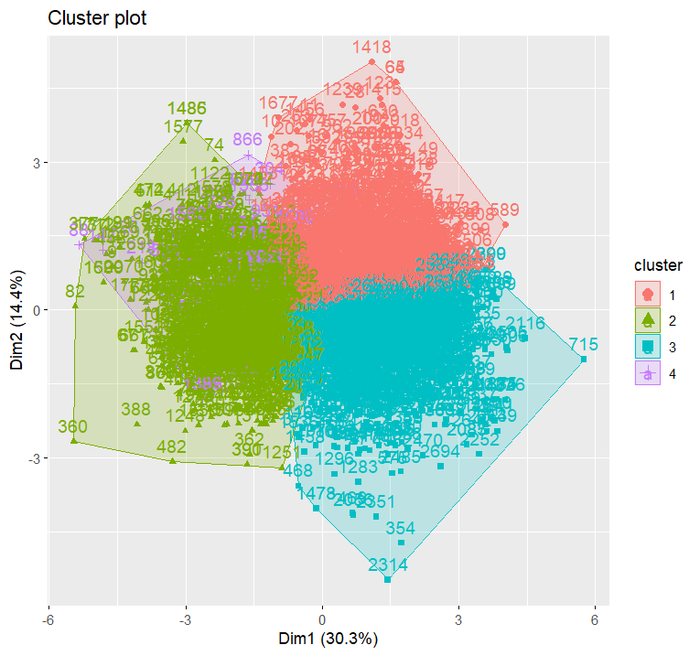

> # Display the BSS/TSS ratio

> BSS <- sum(km$betweenss)

> TSS <- sum(km$totss)

> BSS_TSS_ratio <- BSS/TSS

> cat("The ratio of between_cluster_sums_of_squares (BSS) over total_sum_of_squares (TSS) is", BSS_TSS_ratio, "\n")

The ratio of between_cluster_sums_of_squares (BSS) over total_sum_of_squares (TSS) is 0.342122

>

> # Display the BSS and WSS indices

> cat("The between_cluster_sums_of_squares (BSS) index is", BSS, "\n")

The between_cluster_sums_of_squares (BSS) index is 10157.26

> cat("The within_cluster_sums_of_squares (WSS) index is", km$tot.withinss, "\n")

The within_cluster_sums_of_squares (WSS) index is 19531.74

>

> # Plot the WSS for k = 4

> fviz_nbclust(standardized_features, kmeans, method = "wss") +

+ ggtitle("WSS Plot") +

+ xlab("Number of clusters") +

+ ylab("Within-cluster sum of squares")

|  |
| --- |
| > # Display the silhouette plot  > # Compute silhouette values  > sil <- silhouette(km$cluster, dist(standardized_features))  >  > # Plot the silhouette  > fviz_silhouette(sil)  cluster size ave.sil.width  1 1 798 0.14  2 2 967 0.22  3 3 880 0.12  4 4 55 0.34 |
|  |
| |  | | --- | | > | |

> # Calculate average silhouette width

> average_silhouette_width <- mean(sil[, "sil_width"])

> cat("Average silhouette width:", average_silhouette_width)

Average silhouette width: 0.1622155

Silhouette plot and the computed average silhouette widths:

* We have identified four clusters, each with varying sizes: Cluster 1 (798 data points), Cluster 2 (967 data points), Cluster 3 (880 data points), and Cluster 4 (55 data points).
* The average silhouette width across all clusters is 0.1622155.
* Cluster 4 has the highest average silhouette width (0.34), indicating that the data points in this cluster are well-clustered and have high cohesion and separation compared to the other clusters.
* Cluster 2 also shows a relatively high average silhouette width (0.22), suggesting good clustering.
* Cluster 1 and Cluster 3 have lower average silhouette widths (0.14 and 0.12, respectively), indicating that the data points in these clusters are closer to neighboring clusters.

Overall, the average silhouette width of 0.1622155 suggests a moderate level of clustering quality, with some clusters showing better separation and cohesion than others.

**2nd Subtask - PCA Analaysis**

To conduct PCA analysis, we begin by standardizing the features, and then use prcomp() function to extract the principal components. We can summarize the results of the PCA analysis by calling the summary() function on the prcomp() object that we created. The output of the summary() function shows the importance of each component, which is represented by the standard deviation, proportion of variance, and cumulative proportion.

> # PCA analysis

> pca_result <- prcomp(standardized_features, center = TRUE)

> print(summary(pca_result))

Importance of components:

PC1 PC2 PC3 PC4 PC5 PC6 PC7 PC8 PC9 PC10 PC11

Standard deviation 1.8242 1.2570 1.1075 1.0147 0.98393 0.95690 0.8298 0.74653 0.63217 0.54177 0.11613

Proportion of Variance 0.3025 0.1436 0.1115 0.0936 0.08801 0.08324 0.0626 0.05066 0.03633 0.02668 0.00123

Cumulative Proportion 0.3025 0.4461 0.5576 0.6512 0.73926 0.82250 0.8851 0.93576 0.97209 0.99877 1.00000

|  |
| --- |
| # Print eigenvalues and eigenvectors  > print(pca_result$sdev) #this print the eigenvalues  [1] 1.8241912 1.2569766 1.1074657 1.0146754 0.9839284 0.9569032 0.8298009  [8] 0.7465269 0.6321703 0.5417698 0.1161261  > print(pca_result$rotation)#this prints the eigenvectors  PC1 PC2 PC3 PC4  fixed acidity -0.17409345 0.57068553 0.087247713 0.209430682  volatile acidity -0.01016873 -0.04701333 -0.667603697 0.061110370  citric acid -0.12950667 0.34294115 0.520359898 0.003189287  residual sugar -0.42544819 -0.03080478 -0.209924618 0.175014970  chlorides -0.21811880 0.03812122 0.006272862 -0.758094988  free sulfur dioxide -0.29885491 -0.30122472 0.147705942 0.380551214  total sulfur dioxide -0.40403330 -0.24982649 0.024873354 0.226699978  density -0.50832743 -0.02467803 -0.051425500 -0.060220958  pH 0.14858189 -0.57741901 0.195709942 -0.163980752  sulphates -0.02602988 -0.25271766 0.410360266 0.076628530  alcohol 0.43649289 0.03254900 -0.005725580 0.338312875  PC5 PC6 PC7 PC8  fixed acidity 0.20466350 -0.1691181 0.2528023 -0.56140981  volatile acidity 0.56311078 0.1971664 -0.3184433 -0.13761562  citric acid 0.10591093 0.3127275 -0.6752618 0.03117685  residual sugar -0.13074005 -0.2738351 -0.3288721 0.36160560  chlorides 0.20213482 0.3607222 0.1601849 0.07222723  free sulfur dioxide -0.10605033 0.5047138 0.2199839 0.08639415  total sulfur dioxide 0.10941555 0.2807351 0.1242957 -0.29862242  density -0.04827851 -0.3337286 -0.1442155 -0.06474637  pH -0.05957859 -0.1683622 -0.3408029 -0.57671562  sulphates 0.72411959 -0.3428958 0.1697914 0.29504600  alcohol 0.13565577 0.1969097 -0.1235886 0.09191924  PC9 PC10 PC11  fixed acidity -0.31196772 -0.12199248 0.175362607  volatile acidity 0.12383398 -0.23777976 0.008402549  citric acid 0.16490149 -0.03979703 0.009611698  residual sugar -0.41269261 0.15471137 0.467013298  chlorides -0.40438749 0.10110071 0.024859732  free sulfur dioxide -0.21364329 -0.53399998 -0.025963500  total sulfur dioxide 0.24411170 0.68210746 0.045413969  density -0.07085401 -0.06888076 -0.765677786  pH -0.25938101 -0.10434956 0.143207351  sulphates 0.02244379 -0.03589486 0.039857346  alcohol -0.59014224 0.35424492 -0.373188404 |
|  |
| |  | | --- | |  | |

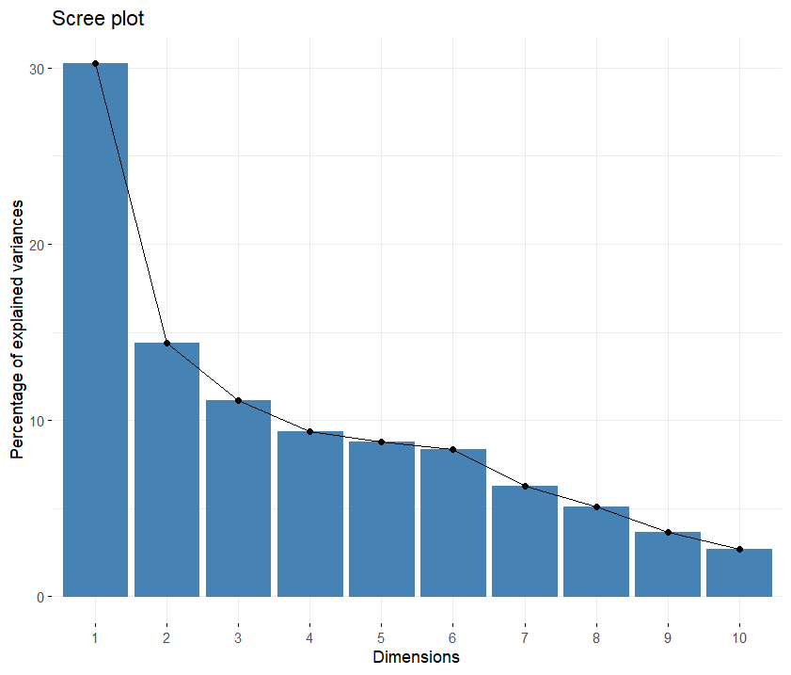

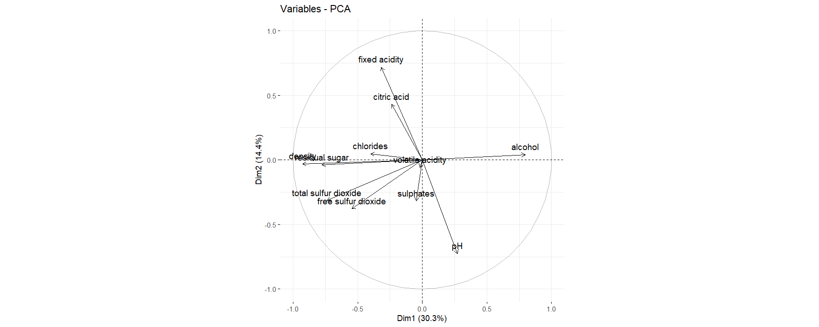

|  |
| --- |
| # Calculate cumulative variance explained by each principal component  > cumulative_variance <- cumsum(pca_result$sdev^2 / sum(pca_result$sdev^2))  >  > # Find the number of principal components required to achieve cumulative score > 0.85  > pc_cutoff <- min(which(cumulative_variance > 0.85))  >  > # Select principal components  > selected_pcs <- paste0("PC", 1:pc_cutoff)  >  > # Create a transformed dataset with only the selected principal components as attributes  > transformed_dataset <- predict(pca_result, standardized_features)[, 1:pc_cutoff]  > colnames(transformed_dataset) <- selected_pcs  >  > # Print selected PCs  > print(selected_pcs)  [1] "PC1" "PC2" "PC3" "PC4" "PC5" "PC6" "PC7"  >  > # Print transformed dataset with selected PCs  > head(transformed_dataset)  PC1 PC2 PC3 PC4 PC5 PC6 PC7  [1,] -144.01001 -1.919518 -25.19102 -6.488273 -21.951113 -96.70759 -41.957092  [2,] 24.03465 4.551442 -12.35863 19.761717 9.851178 16.06237 -12.935786  [3,] -204.28496 3.371050 -22.80745 -238.325428 52.393641 15.95704 4.197964  [4,] 24.03465 4.551442 -12.35863 19.761717 9.851178 16.06237 -12.935786  [5,] -144.01001 -1.919518 -25.19102 -6.488273 -21.951113 -96.70759 -41.957092  [6,] -213.88575 4.936130 -12.31008 -11.934805 -20.938769 -132.15376 -82.067643 |
|  |
| |  | | --- | | > | |

The cumulative variance explained by each principal component was computed, revealing that the first seven principal components were necessary to achieve a cumulative score exceeding 85%. These selected principal components denoted as PC1 to PC7, were then utilized to create a transformed dataset. This transformed dataset, comprising observations represented in the space of the selected principal components, exemplifies the data's reduced dimensionality while retaining significant information. Each row of the transformed dataset corresponds to an observation, while each column represents a selected principal component, facilitating a compact representation of the dataset's variability.

For our upcoming attempt, we have chosen the above components as new features to be clustered. As we have a new dataset, it is necessary to determine the appropriate k for our k-means clustering attempt. To accomplish this, we will apply the same four automated tools that we utilized earlier to this new PCA-based dataset.

NB Clust

> # Determine the number of clusters using NbClust

> nb_clusters <- NbClust(transformed_dataset, distance = "euclidean", min.nc = 2, max.nc = 10, method = "complete", index = "all")

*** : The Hubert index is a graphical method of determining the number of clusters.

In the plot of Hubert index, we seek a significant knee that corresponds to a

significant increase of the value of the measure i.e the significant peak in Hubert

index second differences plot.

*** : The D index is a graphical method of determining the number of clusters.

In the plot of D index, we seek a significant knee (the significant peak in Dindex

second differences plot) that corresponds to a significant increase of the value of

the measure.

*******************************************************************

* Among all indices:

* 9 proposed 2 as the best number of clusters

* 3 proposed 3 as the best number of clusters

* 2 proposed 5 as the best number of clusters

* 3 proposed 6 as the best number of clusters

* 2 proposed 7 as the best number of clusters

* 3 proposed 8 as the best number of clusters

* 2 proposed 10 as the best number of clusters

***** Conclusion *****

* According to the majority rule, the best number of clusters is 2

*******************************************************************

> print(nb_clusters)

$All.index

KL CH Hartigan CCC Scott Marriot TrCovW TraceW Friedman Rubin Cindex DB

2 14.0364 5243.068 670.8752 -10.2886 3375.911 3.008727e+37 1.403763e+14 45293649 291747.1 2.9433 0.1930 0.7099

3 1.1353 3607.495 551.7370 -45.2890 4105.731 5.166232e+37 8.522332e+13 36273907 324465.4 3.6752 0.2350 0.7588

4 1.7003 3079.767 375.3215 -96.8641 4769.455 7.182763e+37 5.600638e+13 30113465 347935.2 4.4270 0.2395 0.7247

5 2.5374 2724.206 69.1071 -133.2133 7427.825 4.192888e+37 4.902335e+13 26433540 359562.1 5.0433 0.2362 0.7495

6 0.0595 2248.236 2370.0926 -167.5654 7556.026 5.757774e+37 4.644758e+13 25772659 362453.9 5.1727 0.2942 0.6601

7 3.1337 3915.362 1061.8154 -119.0358 9583.459 3.698588e+37 1.130488e+13 13710560 404779.0 9.7234 0.2623 0.6711

8 11.7303 4829.156 13.2395 -95.2686 10813.349 3.063319e+37 5.124969e+12 9833383 426054.6 13.5572 0.2452 0.7123

9 10.9825 4246.370 89.4128 -98.6954 10846.012 3.830395e+37 5.066832e+12 9785258 426419.6 13.6239 0.2515 0.8017

10 0.0135 3908.448 729.1802 -99.3776 10978.987 4.501627e+37 4.688061e+12 9470583 428204.5 14.0766 0.2620 0.7798

Silhouette Duda Pseudot2 Beale Ratkowsky Ball Ptbiserial Frey McClain Dunn Hubert SDindex Dindex SDbw

2 0.5591 0.5616 846.3109 3.5615 0.4955 22646824.6 0.6433 1.4650 0.3698 0.0160 0 0.0116 109.3617 1.1251

3 0.4612 0.7508 535.0413 1.5145 0.4269 12091302.3 0.6297 0.6796 0.4438 0.0166 0 0.0140 96.7515 0.8801

4 0.3352 0.6540 456.6082 2.4130 0.3806 7528366.2 0.6342 0.0446 0.4943 0.0170 0 0.0135 88.9606 0.5898

5 0.3530 0.3332 80.0524 8.9150 0.3696 5286708.0 0.6452 0.0669 0.4950 0.0174 0 0.0145 85.4785 0.4420

6 0.3531 0.3412 2915.6097 8.8104 0.3386 4295443.2 0.6453 0.9927 0.4950 0.0217 0 0.0128 84.7702 0.3229

7 0.3933 0.3499 1525.3357 8.4727 0.3293 1958651.4 0.5739 0.7964 0.7942 0.0241 0 0.0156 63.3366 0.2643

8 0.3989 0.5080 5.8109 3.7903 0.3121 1229172.8 0.5422 0.2123 0.9076 0.0263 0 0.0189 53.2771 0.2273

9 0.3974 0.6572 114.2427 2.3710 0.2943 1087250.9 0.5422 0.4731 0.9076 0.0270 0 0.0184 53.2026 0.1866

10 0.3903 0.4298 1054.9045 6.0510 0.2795 947058.3 0.5418 1.1309 0.9085 0.0282 0 0.0209 52.6166 0.1591

$All.CriticalValues

CritValue_Duda CritValue_PseudoT2 Fvalue_Beale

2 0.8602 176.1020 0.0008

3 0.8690 242.9647 0.1571

4 0.8544 147.1042 0.0182

5 0.6609 20.5259 0.0000

6 0.8677 230.2510 0.0000

7 0.8530 141.4975 0.0000

8 0.3404 11.6263 0.0028

9 0.8009 54.4553 0.0207

10 0.8521 138.0087 0.0000

$Best.nc

KL CH Hartigan CCC Scott Marriot TrCovW TraceW Friedman Rubin Cindex DB

Number_clusters 2.0000 2.000 6.000 2.0000 5.00 5.000000e+00 3.000000e+00 7 7.00 8.0000 2.000 6.0000

Value_Index 14.0364 5243.068 2300.985 -10.2886 2658.37 4.554761e+37 5.515297e+13 8184923 42325.03 -3.7671 0.193 0.6601

Silhouette Duda PseudoT2 Beale Ratkowsky Ball PtBiserial Frey McClain Dunn Hubert SDindex Dindex

Number_clusters 2.0000 8.000 8.0000 3.0000 2.0000 3 6.0000 2.000 2.0000 10.0000 0 2.0000 0

Value_Index 0.5591 0.508 5.8109 1.5145 0.4955 10555522 0.6453 1.465 0.3698 0.0282 0 0.0116 0

SDbw

Number_clusters 10.0000

Value_Index 0.1591

$Best.partition

[1] 1 2 1 2 1 1 2 2 1 1 2 2 2 1 2 2 2 1 1 2 1 1 2 2 1 1 1 2 2 2 2 2 2 2 2 1 1 1 1 1 2 2 2 1 1 2 2 2 2 1 1 2 1 2 2 2 2 2 2 2

[61] 2 1 1 2 2 1 1 1 2 2 2 2 1 1 1 1 2 1 2 2 2 1 1 1 1 2 1 1 2 1 2 1 2 2 1 1 2 1 1 1 2 1 1 1 1 1 1 1 1 2 2 1 1 2 2 2 1 1 2 2

[121] 1 1 2 1 1 1 1 1 2 1 1 2 1 2 1 2 2 2 1 2 1 2 2 1 2 1 1 2 1 1 1 1 1 2 2 1 1 1 2 1 1 1 1 2 2 1 1 2 1 1 1 1 1 2 2 2 1 1 1 1

[181] 1 2 2 1 1 1 2 1 1 1 1 1 2 2 1 1 1 1 2 2 2 1 1 1 1 1 1 1 1 1 2 2 2 2 2 2 2 1 1 1 1 2 1 2 2 2 2 2 2 2 1 1 1 1 1 2 2 1 1 2

[241] 1 2 1 2 2 2 1 1 1 2 2 1 1 2 1 1 2 1 1 1 1 1 1 1 1 2 1 1 1 1 1 1 2 1 2 1 1 1 1 1 1 2 2 1 1 2 1 1 1 1 1 1 1 1 1 2 2 1 1 1

[301] 1 1 1 1 2 1 2 1 1 1 2 2 1 2 2 2 1 1 1 2 1 1 1 1 1 1 1 1 1 2 1 1 1 1 2 1 1 1 1 1 1 1 1 1 1 1 1 2 1 1 1 1 1 2 1 1 1 2 2 1

[361] 1 2 1 1 2 1 1 2 1 1 1 1 2 2 1 1 1 1 1 1 1 1 1 1 2 1 2 1 1 1 1 1 1 1 1 1 1 1 2 1 2 2 1 1 1 1 1 2 2 2 1 1 2 2 2 2 1 1 2 2

[421] 1 1 1 1 1 1 2 1 1 2 1 1 2 2 1 1 1 2 1 2 1 1 2 1 2 1 2 2 2 2 2 1 1 1 2 2 2 2 2 1 1 1 1 2 1 1 2 2 2 1 1 1 1 1 1 2 1 2 1 2

[481] 1 1 2 1 1 2 2 1 2 1 1 1 1 1 1 2 1 1 1 1 1 1 2 1 1 2 1 2 2 2 2 2 2 1 1 1 1 1 1 1 1 1 1 1 1 2 2 2 1 1 1 1 1 1 2 2 2 1 1 1

[541] 2 2 1 2 2 2 2 2 1 1 1 1 2 1 1 2 1 1 1 2 2 1 2 2 1 1 1 2 2 2 2 2 2 1 2 2 2 2 2 2 1 2 2 1 2 1 1 2 2 2 1 2 2 2 1 1 2 1 2 1

[601] 2 2 2 2 2 1 2 2 2 2 1 2 1 2 2 1 1 2 2 2 2 2 1 2 1 2 2 2 2 2 2 2 2 2 2 1 2 2 1 2 1 2 1 1 1 1 2 2 1 2 2 2 2 1 1 1 1 1 2 2

[661] 1 1 1 1 2 1 1 1 2 2 1 1 2 2 1 1 2 1 1 2 1 1 1 1 1 1 1 1 2 2 1 2 2 1 1 1 1 1 2 1 2 1 2 2 2 1 2 2 1 2 2 1 1 2 2 1 1 2 1 1

[721] 2 2 2 2 1 1 2 1 2 2 2 2 2 2 2 2 1 1 1 1 2 1 2 1 1 1 1 1 1 1 2 1 2 2 2 2 2 1 2 2 2 2 1 1 2 1 2 2 2 2 2 2 2 1 1 1 1 1 1 1

[781] 1 1 2 1 2 2 2 2 2 2 1 1 2 2 2 2 1 1 1 1 1 2 2 1 2 1 1 2 2 1 1 2 2 2 2 2 2 1 2 2 1 2 2 2 1 1 2 2 2 2 1 1 1 2 2 2 2 2 1 2

[841] 1 2 2 2 1 1 2 2 1 2 2 1 1 1 1 2 1 1 2 2 2 2 2 2 2 1 1 1 2 2 2 2 1 2 1 1 1 1 2 1 1 2 1 1 1 1 2 2 2 1 1 2 1 1 2 1 1 1 2 1

[901] 1 1 2 1 1 1 1 1 2 1 1 1 1 2 2 1 2 1 1 1 1 2 1 1 1 1 1 1 2 2 2 2 1 1 2 1 2 1 2 2 2 2 1 1 1 2 2 1 2 2 1 2 1 1 2 2 1 1 2 2

[961] 1 2 2 1 1 1 1 1 1 1 1 1 1 1 1 1 1 2 2 1 2 2 2 2 2 2 2 2 2 2 2 1 2 1 1 1 1 1 2 2

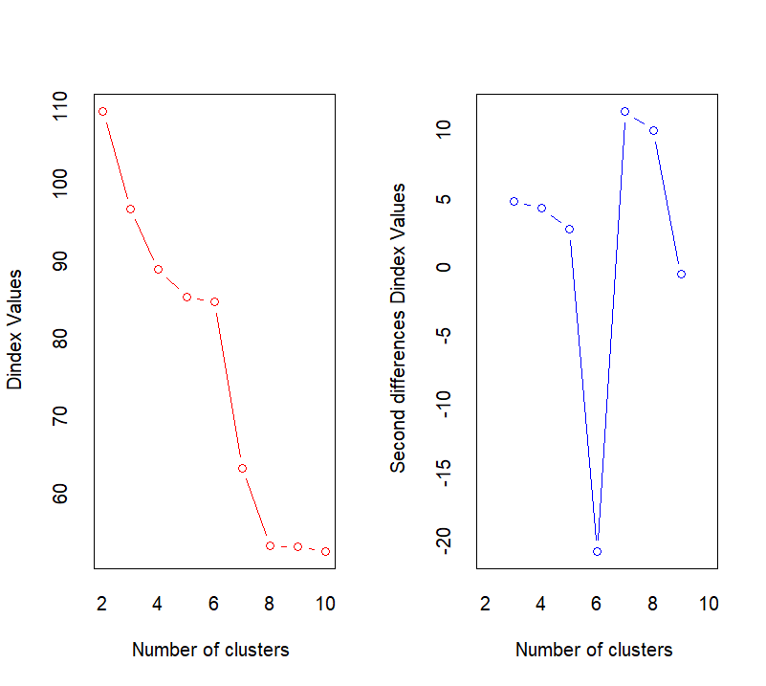 [ reached getOption("max.print") -- omitted 1700 entries ]

Elbow Method

Gap cluster

# Compute gap statistics with increased number of bootstrap replicates

> gap <- clusGap(transformed_dataset, FUN = function(x, k) kmeans(x, k, iter.max = 100), K.max = 10, B = 100)

Clustering k = 1,2,..., K.max (= 10): .. done

Bootstrapping, b = 1,2,..., B (= 100) [one "." per sample]:

.................................................. 50

.................................................. 100

>

> # Plot the gap statistics

> plot(gap, main = "Gap statistic for k-means clustering")

>

> # Determine the optimal number of clusters using maxSE function

> best_clusters <- maxSE(gap$Tab[, "gap"], gap$Tab[, "SE.sim"], method = "Tibs2001SEmax")

>

> # Check contents of best_clusters list

> str(best_clusters)

int 6

Silhouette Method

For K=2

> # Add k=2

> k <- 2

> set.seed(123) # Set the seed for reproducibility

> km <- kmeans(transformed_dataset, centers = k, nstart = 25)

> fviz_cluster(km, data = transformed_dataset)

> print(km)

K-means clustering with 2 clusters of sizes 1205, 1495

Cluster means:

PC1 PC2 PC3 PC4 PC5 PC6 PC7

1 -167.0028 -6.801375 -16.29043 -29.37453 -12.144097 -102.36826 -44.77182

2 134.6076 5.482045 13.13042 23.67646 9.788386 82.51087 36.08698

Clustering vector:

[1] 1 2 1 2 1 1 2 2 1 1 2 1 2 1 2 2 2 1 1 2 1 1 2 2 1 1 1 2 2 2 2 2 2 2 2 1 1 1

[39] 1 1 2 2 2 1 1 2 2 2 2 1 1 2 1 2 2 2 2 2 2 2 2 1 1 2 2 1 1 1 1 1 1 2 1 1 1 1

[77] 1 1 2 2 2 1 1 1 1 2 1 1 2 1 2 1 2 2 1 1 2 1 1 1 2 1 1 1 1 1 1 1 1 2 2 1 1 2

[115] 1 1 2 1 2 2 1 1 2 1 1 1 1 1 2 1 1 2 1 2 1 1 2 2 1 2 1 2 2 1 2 1 1 2 1 1 1 1

[153] 1 1 1 1 1 1 2 1 1 1 1 1 2 1 1 2 1 1 1 1 1 2 2 2 1 1 1 1 1 2 2 1 1 1 2 1 1 1

[191] 1 1 2 2 1 1 1 1 2 2 2 1 1 1 1 1 1 1 1 1 2 2 1 1 2 2 2 1 1 2 1 2 1 2 2 2 1 2

[229] 1 2 1 1 1 1 1 2 2 1 1 2 1 2 1 2 2 2 1 1 1 1 1 1 1 2 1 1 2 1 1 1 1 1 1 1 1 2

[267] 1 1 1 1 1 1 2 1 2 1 1 1 1 1 1 2 2 1 1 2 1 1 1 1 1 1 1 1 1 1 1 1 1 1 1 1 1 2

[305] 2 1 2 1 1 1 2 1 1 2 2 2 1 1 1 1 1 1 1 1 1 1 1 1 1 2 1 1 1 1 1 1 1 1 1 1 1 1

[343] 1 1 1 1 1 2 1 1 1 1 1 2 1 1 1 1 2 1 1 2 1 1 2 1 1 2 1 2 1 1 1 1 1 1 1 1 1 1

[381] 1 1 1 1 2 1 2 1 1 1 1 1 1 1 1 1 1 1 2 1 2 2 1 1 1 1 1 2 2 2 1 1 2 2 1 2 1 1

[419] 1 2 1 1 1 1 1 1 2 1 1 2 1 1 1 2 1 1 1 1 1 1 1 1 2 1 2 1 2 2 2 1 2 1 1 1 2 1

[457] 2 2 2 1 1 1 1 2 1 1 2 2 2 1 1 1 1 1 1 1 1 2 1 2 1 1 2 1 1 2 2 1 2 1 1 1 1 1

[495] 1 2 1 1 1 1 1 1 2 1 1 2 1 1 2 2 2 2 2 1 1 1 1 1 1 1 1 1 1 1 1 2 2 2 2 1 1 1

[533] 1 1 2 2 2 1 1 1 2 2 1 1 2 2 2 2 1 1 1 1 2 1 1 2 1 1 1 2 1 1 2 2 1 1 1 2 1 2

[571] 2 2 1 1 2 2 2 2 2 2 1 2 1 1 2 1 1 2 2 2 1 1 1 1 1 1 2 1 2 1 2 2 1 2 2 1 2 2

[609] 2 2 1 2 1 2 2 1 1 2 2 2 2 2 1 2 1 1 2 2 1 2 2 2 2 2 2 1 2 2 1 2 1 2 1 1 1 1

[647] 2 2 1 2 2 2 2 1 1 1 1 1 2 2 1 1 1 1 2 1 1 1 2 2 1 1 2 2 1 1 2 1 1 2 1 1 1 1

[685] 1 1 1 2 2 2 1 2 2 1 1 1 1 1 2 1 2 1 2 2 2 1 1 2 1 1 2 1 1 2 2 1 1 2 1 1 2 2

[723] 2 2 1 2 2 1 2 2 2 2 2 2 2 2 1 1 1 1 2 1 2 1 1 1 1 1 1 1 2 1 2 2 2 2 2 1 2 2

[761] 2 2 1 1 2 1 2 2 2 1 2 1 2 1 1 1 1 1 1 1 1 1 2 1 2 2 2 2 2 2 1 1 2 2 2 2 1 1

[799] 1 1 1 2 1 1 2 1 1 2 2 1 1 1 2 2 2 2 2 1 2 2 1 2 2 2 1 1 2 2 2 2 1 1 1 2 2 2

[837] 2 1 1 2 1 2 2 2 1 1 2 2 1 2 2 1 1 1 1 2 1 1 2 1 2 1 2 2 2 2 1 1 2 2 2 1 1 2

[875] 1 1 1 1 1 1 1 2 1 1 1 1 2 2 2 1 1 1 1 1 2 1 1 1 1 1 1 1 2 1 1 1 1 1 2 1 1 1

[913] 1 2 2 1 2 1 1 1 1 2 1 1 1 1 1 1 2 2 2 2 1 1 2 1 2 1 2 2 2 2 2 2 1 2 2 1 2 2

[951] 2 2 1 1 2 2 1 1 2 2 1 2 2 1 1 1 1 1 1 1 1 1 1 1 1 1 1 2 2 1 2 2 2 2 2 2 1 2

[989] 2 2 2 1 2 1 1 1 1 1 2 2

[ reached getOption("max.print") -- omitted 1700 entries ]

Within cluster sum of squares by cluster:

[1] 21825249 20747870

(between_SS / total_SS = 68.1 %)

Available components:

[1] "cluster" "centers" "totss" "withinss" "tot.withinss"

[6] "betweenss" "size" "iter" "ifault"

> print(km$centers)

PC1 PC2 PC3 PC4 PC5 PC6 PC7

1 -167.0028 -6.801375 -16.29043 -29.37453 -12.144097 -102.36826 -44.77182

2 134.6076 5.482045 13.13042 23.67646 9.788386 82.51087 36.08698

>

> # Display the BSS/TSS ratio

> BSS <- sum(km$betweenss)

> WSS<-sum(km$tot.withinss)

> TSS <- sum(km$totss)

> BSS_TSS_ratio <- BSS/TSS

> WSS_TSS_ratio <- WSS/TSS

> cat("The ratio of between_cluster_sums_of_squares (BSS) over

+ total_sum_of_squares (TSS) is", BSS_TSS_ratio, "\n")

The ratio of between_cluster_sums_of_squares (BSS) over

total_sum_of_squares (TSS) is 0.6806542

> cat("The ratio of within_cluster_sums_of_squares WSS) over

+ total_sum_of_squares (TSS) is", WSS_TSS_ratio, "\n")

The ratio of within_cluster_sums_of_squares WSS) over

total_sum_of_squares (TSS) is 0.3193458

>

> # Display the BSS and WSS indices

> cat("The between_cluster_sums_of_squares (BSS) index is", BSS, "\n")

The between_cluster_sums_of_squares (BSS) index is 90740422

> cat("The within_cluster_sums_of_squares (WSS) index is", WSS, "\n")

The within_cluster_sums_of_squares (WSS) index is 42573119

K = 3

# Add k=3

> k <- 3

> set.seed(123) # Set the seed for reproducibility

> km <- kmeans(transformed_dataset, centers = k, nstart = 25)

> fviz_cluster(km, data =transformed_dataset)

> print(km)

K-means clustering with 3 clusters of sizes 1006, 672, 1022

Cluster means:

PC1 PC2 PC3 PC4 PC5 PC6 PC7

1 -23.44734 -1.018645 -1.786856 -11.37044 -0.1860167 -10.04448 -3.86489

2 -241.19333 -9.461794 -23.609137 -38.44076 -18.2476460 -150.08983 -65.72846

3 181.67313 7.224151 17.282697 36.46854 12.1815567 108.57644 47.02309

Clustering vector:

[1] 2 1 2 1 2 2 3 1 2 1 1 1 3 1 3 1 1 1 1 1 1 1 3 3 1 2 1 1 1 3 3 3 3 3 3 2 2 1

[39] 1 2 3 1 1 2 2 1 3 1 3 1 2 3 2 1 1 1 1 1 1 1 3 2 2 3 3 1 1 2 1 1 1 1 2 2 2 2

[77] 1 2 3 3 1 2 1 1 1 1 1 2 1 1 1 1 1 1 2 1 1 1 1 1 1 2 2 1 2 1 1 2 2 3 1 1 1 3

[115] 1 1 1 2 1 1 1 2 3 1 1 2 1 1 3 2 1 1 1 1 2 1 3 1 2 1 2 1 3 2 1 2 2 3 2 2 2 2

[153] 1 1 1 1 2 2 1 2 2 2 2 1 1 2 2 1 2 2 2 2 1 1 1 1 2 1 1 2 1 3 3 2 2 2 3 1 2 1

[191] 2 2 1 1 1 2 2 2 1 1 1 1 1 1 1 2 2 2 1 1 3 3 1 1 3 1 1 2 1 1 1 1 2 3 3 1 1 3

[229] 1 3 2 1 1 2 2 3 3 2 2 1 2 3 1 1 1 1 1 1 1 1 1 1 1 1 2 1 1 2 2 2 1 2 1 2 2 1

[267] 1 1 2 2 2 2 1 2 1 2 2 2 1 2 1 3 3 2 2 1 2 2 2 2 1 2 2 1 2 1 1 1 2 1 2 1 1 1

[305] 1 2 1 1 1 1 1 1 2 3 3 1 2 2 1 1 1 2 1 2 2 2 1 1 1 3 2 2 2 2 1 1 1 2 2 2 2 1

[343] 1 2 2 1 2 1 2 1 2 1 2 1 1 2 2 1 3 2 2 1 2 2 3 2 2 3 2 1 1 2 1 1 2 1 2 2 2 1

[381] 2 1 1 2 1 2 3 2 2 2 2 1 1 1 1 1 1 2 1 2 1 1 2 2 2 2 2 1 1 1 2 2 1 1 1 1 1 2

[419] 1 3 2 2 2 2 1 2 3 1 2 1 2 2 1 3 2 2 2 1 2 1 2 2 1 2 1 2 3 3 1 1 3 1 1 2 1 1

[457] 1 1 1 2 2 1 1 3 2 1 3 1 3 2 2 2 2 2 2 1 1 3 1 1 2 2 1 2 1 1 1 1 3 2 2 2 2 2

[495] 2 1 1 2 2 2 2 2 1 2 2 3 2 1 1 3 3 3 3 2 2 1 1 1 1 1 1 1 1 2 2 1 3 3 1 2 1 2

[533] 1 1 1 3 3 2 2 1 3 3 2 1 1 1 3 3 2 1 2 2 3 2 1 1 1 1 1 1 1 1 3 3 1 1 1 1 1 1

[571] 1 1 1 2 1 3 3 1 1 1 1 3 1 1 3 2 2 1 3 3 1 1 1 1 2 2 3 1 1 1 3 3 1 3 3 2 1 3

[609] 1 3 1 1 2 3 3 2 2 1 3 3 3 3 2 1 2 1 3 3 1 3 1 1 1 3 3 2 3 3 2 3 1 3 1 1 1 1

[647] 3 3 2 3 3 3 1 2 2 1 1 2 3 3 2 2 2 2 3 1 2 1 3 3 2 1 3 3 1 2 3 2 2 3 1 1 1 1

[685] 1 1 1 3 1 1 2 3 3 1 1 1 1 2 3 2 3 1 3 1 1 2 1 1 2 1 1 2 2 3 3 2 2 3 2 1 1 1

[723] 1 1 2 1 3 2 3 3 3 3 3 3 3 3 2 2 2 2 3 2 3 2 1 2 1 1 1 1 3 2 3 3 3 3 3 2 1 3

[761] 3 3 2 1 3 1 3 1 1 1 1 1 1 2 2 1 1 1 1 2 1 2 3 2 3 3 1 1 1 1 1 2 3 3 3 3 2 2

[799] 2 1 1 3 1 1 3 2 2 3 3 2 2 1 1 3 3 3 1 1 1 1 1 1 3 3 2 2 1 1 3 1 1 1 1 1 1 3

[837] 3 1 1 1 1 3 1 1 1 1 3 3 2 1 1 1 2 2 2 3 2 2 3 1 3 1 3 3 3 1 2 2 3 1 3 1 2 3

[875] 2 2 2 2 1 2 2 3 2 2 2 1 1 1 3 2 2 1 2 2 1 2 2 2 1 2 1 2 3 2 1 1 1 1 1 1 1 1

[913] 2 3 1 1 3 2 1 2 2 1 1 1 1 1 1 2 1 1 3 3 1 1 1 1 3 2 1 3 1 3 1 1 1 1 1 1 3 3

[951] 1 3 1 2 1 3 1 2 1 3 1 1 1 2 2 2 2 2 2 2 2 2 2 2 2 2 1 3 3 1 1 3 3 3 3 3 1 3

[989] 3 3 1 2 1 2 2 2 2 2 3 3

[ reached getOption("max.print") -- omitted 1700 entries ]

Within cluster sum of squares by cluster:

[1] 9094339 6587322 8133321

(between_SS / total_SS = 82.1 %)

Available components:

[1] "cluster" "centers" "totss" "withinss" "tot.withinss"

[6] "betweenss" "size" "iter" "ifault"

> print(km$centers)

PC1 PC2 PC3 PC4 PC5 PC6 PC7

1 -23.44734 -1.018645 -1.786856 -11.37044 -0.1860167 -10.04448 -3.86489

2 -241.19333 -9.461794 -23.609137 -38.44076 -18.2476460 -150.08983 -65.72846

3 181.67313 7.224151 17.282697 36.46854 12.1815567 108.57644 47.02309

>

> # Display the BSS/TSS ratio

> BSS <- sum(km$betweenss)

> WSS<-sum(km$tot.withinss)

> TSS <- sum(km$totss)

> BSS_TSS_ratio <- BSS/TSS

> WSS_TSS_ratio <- WSS/TSS

>

> cat("The ratio of between_cluster_sums_of_squares (BSS) over

+ total_sum_of_squares (TSS) is", BSS_TSS_ratio, "\n")

The ratio of between_cluster_sums_of_squares (BSS) over

total_sum_of_squares (TSS) is 0.8213611

> cat("The ratio of within_cluster_sums_of_squares WSS) over

+ total_sum_of_squares (TSS) is", WSS_TSS_ratio, "\n")

The ratio of within_cluster_sums_of_squares WSS) over

total_sum_of_squares (TSS) is 0.1786389

>

> # Display the BSS and WSS indices

> cat("The between_cluster_sums_of_squares (BSS) index is", BSS, "\n")

The between_cluster_sums_of_squares (BSS) index is 109498559

> cat("The within_cluster_sums_of_squares (WSS) index is", WSS, "\n")

The within_cluster_sums_of_squares (WSS) index is 23814982

For K = 4

|  |
| --- |
| # Add k=4  > k <- 4  > set.seed(123) # Set the seed for reproducibility  > km <- kmeans(transformed_dataset, centers = k, nstart = 25)  > fviz_cluster(km, data = transformed_dataset)  > print(km)  K-means clustering with 4 clusters of sizes 529, 584, 740, 847  Cluster means:  PC1 PC2 PC3 PC4 PC5 PC6 PC7  1 -264.96200 -10.294026 -25.907290 -42.441383 -19.929052 -164.62898 -72.24676  2 228.91312 8.930601 20.842027 46.429379 15.737057 136.67631 59.01978  3 -83.26944 -3.816659 -8.352903 -17.475030 -5.710557 -49.61930 -21.38539  4 80.40026 3.606135 9.107864 9.761813 6.585406 51.93394 23.11237  Clustering vector:  [1] 3 4 3 4 3 1 4 4 1 3 4 3 4 3 4 4 4 3 3 4 3 3 2 2 3 1 3 4 4 4 4 4 4 4 4 1 1 3  [39] 3 1 4 4 4 1 3 4 4 4 2 3 1 4 3 4 4 4 4 3 4 4 4 1 1 4 4 3 3 1 3 3 3 4 1 1 1 1  [77] 3 1 2 2 3 1 3 3 3 4 3 1 4 3 3 3 4 4 3 3 4 3 3 3 3 1 1 3 3 3 3 1 1 4 4 3 3 2  [115] 3 3 4 1 4 4 3 3 4 3 3 3 3 3 4 1 3 4 3 3 1 3 4 3 1 3 1 3 4 1 3 1 1 4 1 3 1 1  [153] 3 3 3 3 1 1 4 1 1 1 1 3 4 1 1 4 1 1 1 1 3 3 4 4 3 3 3 3 3 4 4 3 3 3 4 3 1 3  [191] 1 3 4 4 3 1 1 1 4 4 4 3 3 3 3 1 1 1 3 3 4 4 3 3 4 4 4 1 3 4 3 3 1 4 4 3 3 4  [229] 3 4 1 3 3 1 1 4 4 1 3 4 3 2 3 4 4 4 3 3 3 3 3 3 3 4 3 3 4 1 1 1 3 1 3 1 1 4  [267] 3 3 1 1 1 1 4 1 4 3 1 3 3 1 3 4 4 3 3 4 1 1 1 1 3 1 1 3 1 3 3 3 1 3 1 3 3 4  [305] 4 1 4 3 3 3 4 3 1 4 4 4 1 1 3 3 3 3 3 1 1 1 3 3 3 4 1 1 1 1 3 3 3 1 1 1 1 3  [343] 3 1 1 3 1 4 1 3 1 3 1 3 3 3 3 3 2 1 1 3 1 1 4 1 1 4 1 4 3 1 3 3 3 3 1 1 1 3  [381] 1 3 3 1 4 1 4 1 3 1 1 3 3 3 3 3 3 1 4 1 4 4 3 3 1 1 1 4 4 4 1 1 4 3 3 4 3 3  [419] 3 4 3 1 1 1 3 1 4 3 1 4 1 1 3 4 1 3 3 3 1 3 3 1 4 3 4 1 4 4 4 3 4 3 3 1 4 3  [457] 4 3 3 1 3 3 3 2 1 3 2 4 4 1 1 1 1 1 3 3 3 4 3 4 1 1 3 1 3 4 4 3 4 1 1 1 1 1  [495] 1 4 3 1 1 1 1 1 4 1 1 2 1 3 4 4 4 2 2 1 1 3 3 3 3 3 3 3 3 1 1 4 2 4 4 3 3 3  [533] 3 3 4 2 4 1 1 3 2 4 3 3 4 3 4 4 1 3 3 1 2 1 3 4 3 3 3 4 3 3 4 4 3 3 3 4 3 4  [571] 4 4 3 1 4 2 2 4 4 3 3 4 3 3 2 1 1 3 2 4 3 3 3 3 1 1 2 3 3 3 2 4 3 2 4 1 4 2  [609] 4 2 3 4 1 2 2 3 3 4 4 4 4 2 3 4 3 3 2 2 3 2 4 4 4 4 2 1 4 4 1 4 3 2 3 3 3 3  [647] 2 4 3 4 2 4 4 1 1 3 3 3 4 4 3 1 1 1 2 3 1 3 2 4 1 3 2 2 3 1 4 1 1 2 3 3 3 3  [685] 3 3 3 4 4 4 3 4 4 3 3 3 3 1 2 1 2 3 4 4 4 1 3 4 1 3 4 1 1 4 2 3 1 2 1 3 4 4  [723] 4 4 1 4 2 1 4 4 4 4 4 4 4 2 1 1 1 1 2 1 4 1 3 1 3 3 3 3 4 3 4 4 4 4 4 3 4 2  [761] 4 4 3 3 2 3 2 4 4 3 3 3 3 1 1 3 3 3 3 1 3 3 2 3 4 4 4 4 4 4 3 1 4 4 4 2 1 1  [799] 1 3 3 2 3 3 2 1 1 4 2 1 1 3 4 4 4 4 3 3 3 4 3 4 2 4 1 1 4 4 4 4 3 3 3 4 4 4  [837] 2 3 3 4 3 4 4 4 3 3 2 4 1 4 4 3 1 3 3 4 3 1 4 3 4 3 4 4 2 4 1 1 4 4 2 3 1 4  [875] 1 1 1 1 3 1 1 4 1 1 1 3 4 4 2 1 1 3 1 1 4 1 1 1 3 1 3 3 2 3 3 3 3 3 3 3 3 3  [913] 1 4 4 3 4 3 3 3 1 4 3 3 3 3 3 1 4 4 4 4 3 3 4 3 2 1 4 4 4 2 4 4 3 4 4 3 4 2  [951] 4 2 3 1 4 4 3 1 4 4 3 4 4 1 3 1 1 1 1 1 3 1 1 1 1 1 3 2 2 3 4 2 4 4 4 4 3 4  [989] 2 4 4 3 4 3 1 1 1 1 2 4  [ reached getOption("max.print") -- omitted 1700 entries ]  Within cluster sum of squares by cluster:  [1] 4243423 2887203 4463655 4643832  (between_SS / total_SS = 87.8 %)  Available components:  [1] "cluster" "centers" "totss" "withinss" "tot.withinss"  [6] "betweenss" "size" "iter" "ifault"  > print(km$centers)  PC1 PC2 PC3 PC4 PC5 PC6 PC7  1 -264.96200 -10.294026 -25.907290 -42.441383 -19.929052 -164.62898 -72.24676  2 228.91312 8.930601 20.842027 46.429379 15.737057 136.67631 59.01978  3 -83.26944 -3.816659 -8.352903 -17.475030 -5.710557 -49.61930 -21.38539  4 80.40026 3.606135 9.107864 9.761813 6.585406 51.93394 23.11237  >  > # Display the BSS/TSS ratio  > BSS <- sum(km$betweenss)  > WSS<-sum(km$tot.withinss)  > TSS <- sum(km$totss)  > BSS_TSS_ratio <- BSS/TSS  > WSS_TSS_ratio <- WSS/TSS  > cat("The ratio of between_cluster_sums_of_squares (BSS) over  + total_sum_of_squares (TSS) is", BSS_TSS_ratio, "\n")  The ratio of between_cluster_sums_of_squares (BSS) over  total_sum_of_squares (TSS) is 0.8781961  > cat("The ratio of within_cluster_sums_of_squares WSS) over  + total_sum_of_squares (TSS) is", WSS_TSS_ratio, "\n")  The ratio of within_cluster_sums_of_squares WSS) over  total_sum_of_squares (TSS) is 0.1218039  >  > # Display the BSS and WSS indices  > cat("The between_cluster_sums_of_squares (BSS) index is", BSS, "\n")  The between_cluster_sums_of_squares (BSS) index is 117075428  > cat("The within_cluster_sums_of_squares (WSS) index is", WSS, "\n")  The within_cluster_sums_of_squares (WSS) index is 16238113 |
|  |

# Display the BSS/TSS ratio

> BSS <- sum(km$betweenss)

> WSS<-sum(km$tot.withinss)

> TSS <- sum(km$totss)

> BSS_TSS_ratio <- BSS/TSS

> WSS_TSS_ratio <- WSS/TSS

> cat("The ratio of between_cluster_sums_of_squares (BSS) over

+ total_sum_of_squares (TSS) is", BSS_TSS_ratio, "\n")

The ratio of between_cluster_sums_of_squares (BSS) over

total_sum_of_squares (TSS) is 0.8781961

> cat("The ratio of within_cluster_sums_of_squares WSS) over

+ total_sum_of_squares (TSS) is", WSS_TSS_ratio, "\n")

The ratio of within_cluster_sums_of_squares WSS) over

total_sum_of_squares (TSS) is 0.1218039

>

> # Display the BSS and WSS indices

> cat("The between_cluster_sums_of_squares (BSS) index is", BSS, "\n")

The between_cluster_sums_of_squares (BSS) index is 117075428

> cat("The within_cluster_sums_of_squares (WSS) index is", WSS, "\n")

The within_cluster_sums_of_squares (WSS) index is 16238113

>

> # Display the silhouette plot

> # Compute silhouette values

> sil <- silhouette(km$cluster, dist(transformed_dataset))

>

> # Add k=2

> k <- 2

> set.seed(123) # Set the seed for reproducibility

> km <- kmeans(transformed_dataset, centers = k, nstart = 25)

> sil_2 <- silhouette(km$cluster, dist(transformed_dataset))

>

> # Add k=3

> k <- 3

> set.seed(123) # Set the seed for reproducibility

> km <- kmeans(transformed_dataset, centers = k, nstart = 25)

> sil_3 <- silhouette(km$cluster, dist(transformed_dataset))

>

> # Add k=4

> k <- 4

> set.seed(123) # Set the seed for reproducibility

> km <- kmeans(transformed_dataset, centers = k, nstart = 25)

> sil_4 <- silhouette(km$cluster, dist(transformed_dataset))

>

> # Calculate average silhouette width for each scenario

> average_silhouette_width_2 <- mean(sil_2[, "sil_width"])

> average_silhouette_width_3 <- mean(sil_3[, "sil_width"])

> average_silhouette_width_4 <- mean(sil_4[, "sil_width"])

>

> # Print average silhouette widths

> cat("Average silhouette width for k=2:", average_silhouette_width_2, "\n")

Average silhouette width for k=2: 0.5729813

> cat("Average silhouette width for k=3:", average_silhouette_width_3, "\n")

Average silhouette width for k=3: 0.5051656

> cat("Average silhouette width for k=4:", average_silhouette_width_4, "\n")

Average silhouette width for k=4: 0.4710818

>

> # Plot silhouette for k=2

> fviz_silhouette(sil_2)

cluster size ave.sil.width

1 1 1205 0.54

2 2 1495 0.60

>

> # Plot silhouette for k=3

> fviz_silhouette(sil_3)

cluster size ave.sil.width

1 1 1006 0.42

2 2 672 0.55

3 3 1022 0.56

>

> # Plot silhouette for k=4

> fviz_silhouette(sil_4)

cluster size ave.sil.width

1 1 529 0.53

2 2 584 0.52

3 3 740 0.46

4 4 847 0.41

The analysis begins with the examination of the BSS/TSS ratio, revealing a substantial proportion of variance explained by between-cluster differences, with a ratio of 0.878. The BSS and WSS indices further support the notion of well-separated clusters, with BSS at 117,075,428 and WSS at 16,238,113. Evaluating the average silhouette widths for k=2,3, and 44 provides insight into cluster cohesion and separation. For 𝑘=2, the average silhouette width is 0.573, indicating clear separation between clusters. Increasing 𝑘 to 3 and 4 yields average silhouette widths of 0.505 and 0.471, respectively, suggesting reasonable cluster structures. Silhouette plots for each scenario depict the distribution of data points within clusters, affirming the clustering quality. Overall, the analysis supports the conclusion that k=2 yields the most distinct clusters, as evidenced by the superior average silhouette width and well-defined separation.

**The Calinski - Harabasz Index Internal Metric Evaluation**

Clustering validation is essential for assessing clustering algorithms. We focus here on the Calinski-Harabasz (CH) Index, a measure introduced in 1974. It evaluates clustering quality without known labels, using dataset features. The CH Index quantifies how well objects within a cluster are grouped compared to other clusters. It's calculated using the ratio of separation to cohesion, where separation is the distance between cluster centroids and cohesion is the average distance of data points to their centroid.

The calculation of the Calinski-Harabasz index and then the bar plot graph is illustrated to define the Calinski-Harabasz index vs the number of clusters assigned.

|  |
| --- |
| # Calculate the Calinski-Harabasz index for 2-10 clusters  > res <- NbClust(transformed_dataset, diss = NULL, distance = "euclidean", min.nc = 2, max.nc = 10, method = "kmeans", index = "ch")  > print(res)  $All.index  2 3 4 5 6 7 8 9 10  5750.522 6199.867 6479.311 5865.924 6194.741 6808.409 7033.304 6992.658 7024.087  $Best.nc  Number_clusters Value_Index  8.000 7033.304  $Best.partition  [1] 6 5 1 5 6 2 4 5 8 6 5 5 4 6 4 5 5 6 6 4 6 6 7 7 6 2 6 5 4 7 4 7 4 4 7 2 8 5 6 2 4 5 4 8 6 4  [47] 4 4 7 6 8 7 6 4 5 4 4 5 5 4 4 2 2 4 4 6 6 8 5 5 5 4 2 8 2 2 5 2 7 7 5 8 6 6 6 4 6 1 4 6 5 6  [93] 5 4 6 6 5 1 1 6 5 8 2 6 6 6 6 8 2 4 5 1 1 7 5 5 1 2 5 4 6 6 4 6 6 6 6 6 4 8 6 5 6 5 8 5 7 5  [139] 2 5 2 5 4 2 5 2 2 4 2 6 2 8 6 5 5 6 2 2 5 8 8 8 8 5 4 2 8 4 8 8 8 8 6 5 4 4 6 6 6 6 6 4 4 6  [185] 6 6 4 6 8 6 8 6 4 4 6 8 8 2 5 4 4 6 6 6 6 8 8 2 6 6 4 4 5 5 4 4 4 8 1 1 6 5 2 4 4 5 5 4 5 4  [231] 2 6 6 8 8 7 7 8 6 4 6 7 6 4 5 5 6 6 6 5 5 6 6 5 6 6 4 2 2 2 6 2 5 2 2 5 5 6 8 8 8 8 4 8 4 6  [277] 2 6 6 2 6 7 4 6 6 5 2 8 8 2 6 2 8 6 2 5 5 6 8 6 8 6 5 1 4 2 4 6 6 6 5 5 2 7 7 5 2 2 6 5 6 6  [323] 6 2 2 2 6 6 6 4 2 2 2 2 5 6 1 8 8 8 8 1 1 8 2 6 2 5 2 6 2 6 2 5 6 6 6 5 7 8 2 5 2 2 4 2 8 4  [369] 2 1 6 2 6 5 6 6 8 2 2 6 8 6 6 2 5 2 4 8 2 2 2 6 6 6 6 6 1 2 4 2 4 4 6 6 8 2 2 5 5 4 2 2 5 5  [415] 5 4 6 6 5 4 6 8 8 8 5 2 4 6 8 4 8 2 5 4 2 6 6 5 8 5 6 2 4 2 4 8 7 7 4 5 4 6 6 8 4 5 5 5 5 2  [461] 2 6 6 7 8 6 7 4 7 2 2 8 2 8 6 5 6 7 6 4 2 2 5 2 6 4 4 6 4 8 8 8 8 8 8 4 6 8 2 2 2 2 4 2 2 3  [507] 2 5 4 4 4 3 3 8 8 6 6 6 6 6 6 6 6 2 2 4 7 4 1 6 5 6 6 6 4 3 7 2 2 6 7 7 6 5 5 5 7 7 2 6 6 2  [553] 7 2 6 5 6 6 6 5 5 6 4 4 6 6 6 4 5 4 4 4 5 2 5 3 3 4 5 5 6 4 5 6 7 2 2 5 3 7 6 5 5 5 2 2 7 6  [599] 5 6 3 4 5 7 7 2 4 3 4 7 6 4 8 3 3 6 6 4 7 7 7 7 6 5 6 5 3 7 5 3 5 4 4 7 3 2 7 7 2 7 6 7 6 6  [645] 6 6 7 7 6 7 7 4 4 2 2 6 6 6 4 4 6 8 8 8 7 6 8 6 3 7 8 6 3 7 6 2 7 2 2 7 6 6 6 6 6 6 6 1 5 5  [691] 6 4 4 6 6 6 6 2 3 2 3 1 4 5 4 8 5 5 8 5 4 8 2 7 3 6 2 7 8 6 5 5 4 4 8 1 3 2 4 4 4 4 4 4 4 7  [737] 2 2 2 2 3 2 4 2 6 2 6 6 6 6 4 6 7 7 4 7 4 6 4 7 7 7 6 6 7 6 3 4 4 5 5 5 5 2 2 6 6 6 6 2 6 6  [783] 7 2 4 4 5 5 5 5 6 2 4 4 4 7 2 2 8 1 6 7 5 6 7 8 8 4 7 2 2 5 4 7 4 4 5 6 5 4 6 4 3 4 8 8 4 4  [829] 4 4 6 6 6 5 5 4 3 5 5 5 6 4 5 4 6 6 7 7 2 5 5 6 2 6 6 4 6 2 4 5 4 5 7 7 3 1 2 2 4 5 7 5 2 4  [875] 2 2 2 2 5 2 2 7 2 2 2 6 5 5 3 2 2 5 2 2 4 2 8 8 5 8 1 2 3 6 6 6 6 6 5 6 6 6 2 7 4 5 7 6 6 6  [921] 8 5 5 6 6 5 5 8 5 5 4 7 5 6 4 6 7 2 4 7 5 7 1 1 6 4 4 6 7 7 1 7 6 2 4 4 5 2 4 4 6 5 4 2 6 2  [967] 2 2 2 2 6 2 2 2 8 8 6 7 7 6 4 7 4 7 4 7 5 4 3 7 5 6 5 6 2 2 2 2 7 7  [ reached getOption("max.print") -- omitted 1700 entries ]  > print(res$Best.nc)  Number_clusters Value_Index  8.000 7033.304  > # Plot the results  > barplot(res$Best.nc[2], names.arg = res$Best.nc[1], xlab = "Number of clusters", ylab ="Calinski-Harabasz index") |
|  |
| |  | | --- | |  | |

Through the use of the k-means algorithm, various cluster counts were evaluated on a given dataset and the Calinski-Harabasz index was used to determine the best solution. The highest value of the index, 7033.304, was achieved with 8 clusters, indicating that this clustering solution yielded the most distinct and well-defined clusters with minimal within-cluster variance and maximal between-cluster variance. By assigning each observation to a specific cluster, the optimal partition provides a clear understanding of the cluster assignments. This analysis confirms that the 8-cluster partitioning effectively captures the data's inherent structure, making it suitable for further analysis and interpretation.

**Financial Forecasting Part**

Financial forecasting is instrumental in anticipating future exchange rates, a pivotal aspect of global business operations and financial decision-making. Much like weather forecasting, accurate exchange rate predictions empower businesses to plan effectively, optimize currency exchanges, and mitigate financial risks.

Choosing the right input variables for Neural Networks (NNs) in financial forecasting is paramount for precise predictions. These variables, forming the input vector for NNs, significantly influence the model's performance, determining its ability to forecast future exchange rates accurately.

Input variables in financial forecasting encompass a spectrum of factors, including historical exchange rates, economic indicators, market sentiment, and external influences. These variables encapsulate trends, patterns, and factors impacting exchange rate movements. To ensure the forecasting model's precision and reliability, input variables must be meticulously selected and processed. This involves filtering out noise and identifying meaningful patterns through techniques like data cleaning, normalization, and feature engineering.

Commonly employed schemes/methods for defining the input vector in financial forecasting encompass a variety of approaches:

1. AutoRegression Models (AR Models): Leveraging historical exchange rate values as input variables, AR models assume future exchange rate movements depend on past values.
2. Moving Average (MA) Models: Accounting for the influence of previous prediction errors on future exchange rate movements, MA models use a rolling window of historical forecast errors.
3. Time Series Models (ARIMA): Integrating both autoregressive and moving average components, ARIMA models employ differencing to make data stationary before forecasting exchange rates.
4. Seasonal ARIMA (SARIMA) Models: Extending ARIMA models to detect seasonal patterns, SARIMA models utilize seasonal differencing for enhanced forecasting accuracy.
5. ARMA Models: Merging autoregressive and moving average models, ARMA models facilitate statistical analysis and exchange rate forecasting.
6. Exponential Smoothing (ES) Models: Forecasting exchange rates using weighted averages of previous observations, ES models incorporate options to include seasonal patterns and trend elements.
7. Artificial Neural Networks (ANNs): Capable of discerning nonlinear correlations, ANNs utilize historical exchange rate data and external variables for accurate future rate forecasts.

In practice, defining the input vector for NNs in exchange rate forecasting often involves a hybrid approach, combining various methods to capture the market's complex dynamics effectively. The selection of input variables depends on factors such as data availability, forecasting horizon, and data complexity. Each method presents its advantages and drawbacks, necessitating careful consideration based on the specific forecasting requirements. Brownlee, J. (2020, August 28)

For instance, when employing a Multilayer Perceptron Neural Network (MLP-NN) to predict the next day's exchange rate between USD and EUR, the focus typically lies on the autoregressive (AR) approach. In this scenario, past USD/EUR rates serve as crucial input variables for predicting future values. Additionally, lagged variables, technical indicators, fundamental indicators, sentiment analysis, and hybrid models can further enrich the input vector, enhancing the forecasting model's accuracy and reliability.

Performance evaluation metrics such as RMSE, MAE, MAPE, and S-MAPE allow for the comparison of different models, providing insights into how various inputs and neural network structures influence forecasting accuracy.

By judiciously selecting and preprocessing relevant input data, NN models can adeptly anticipate future exchange rate patterns, enabling businesses and financial institutions to optimize currency transactions, reduce costs, and enhance financial decision-making processes.

**Use of normalization**

In financial forecasting, normalization is a critical step to ensure data is on a common scale. This improves model convergence, prevents bias towards larger-scale variables, enhances performance, and maintains numerical stability. Normalization is an essential process for accurate and efficient predictions in financial models, particularly when using Neural Networks.

Min-Max normalization is a scaling technique used in data preprocessing for machine learning. It scales features so that they fall within a range of 0 to 1. The formula used is (Value - Min)/(Max - Min). It helps with algorithm convergence and is useful for distance-based algorithms. However, it's sensitive to outliers and other scaling methods may be necessary.

|  |  |
| --- | --- |
| Before Normalization | After Normalization |
| > # Take only the exchange rate column  > dataset <- as.data.frame(data[[3]])  > head(dataset)  data[[3]]  1 1.3730  2 1.3860  3 1.3768  4 1.3718  5 1.3774  6 1.3672 | > # Normalizing the dataset  > datast_norm <- as.data.frame(lapply(dataset, normalize))  > head(datast_norm)  data..3..  1 0.7909953  2 0.8526066  3 0.8090047  4 0.7853081  5 0.8118483  6 0.7635071 |

**The Input/Output Matrix for the MLP training/testing**

|  |  |
| --- | --- |
|  | **Input/Output Matrix** |
| *T1 Train* | previous_Day1 t1_expected  *<dbl>* *<dbl>*  1 0.791 0.853  2 0.853 0.809  3 0.809 0.785  4 0.785 0.812  5 0.812 0.764  6 0.764 0.858 |
| *T1* *Test* | previous_Day1 t1_expected  *<dbl>* *<dbl>*  1 0.358 0.402  2 0.402 0.381  3 0.381 0.416  4 0.416 0.407  5 0.407 0.415  6 0.415 0.383 |
| *T2 Train* | previous_Day2 previous_Day1 t2_expected  *<dbl>* *<dbl>* *<dbl>*  1 0.791 0.853 0.809  2 0.853 0.809 0.785  3 0.809 0.785 0.812  4 0.785 0.812 0.764  5 0.812 0.764 0.858  6 0.764 0.858 0.887 |
| *T2 Test* | previous_Day2 previous_Day1 t2_expected  *<dbl>* *<dbl>* *<dbl>*  1 0.358 0.402 0.381  2 0.402 0.381 0.416  3 0.381 0.416 0.407  4 0.416 0.407 0.415  5 0.407 0.415 0.383  6 0.415 0.383 0.418 |
| *T3 Train* | previous_Day3 previous_Day2 previous_Day1 t3_expected  *<dbl>* *<dbl>* *<dbl>* *<dbl>*  1 0.791 0.853 0.809 0.785  2 0.853 0.809 0.785 0.812  3 0.809 0.785 0.812 0.764  4 0.785 0.812 0.764 0.858  5 0.812 0.764 0.858 0.887  6 0.764 0.858 0.887 0.877 |
| *T3 Test* | previous_Day3 previous_Day2 previous_Day1 t3expected  *<dbl>* *<dbl>* *<dbl>* *<dbl>*  1 0.358 0.402 0.381 0.416  2 0.402 0.381 0.416 0.407  3 0.381 0.416 0.407 0.415  4 0.416 0.407 0.415 0.383  5 0.407 0.415 0.383 0.418  6 0.415 0.383 0.418 0.465 |

**Statistical Indices**

RMSE, MAE, MAPE, and S-MAPE are statistical indices commonly used to measure the accuracy of predictive models, especially in regression analysis.

**RMSE (Root Mean Square Error)**

RMSE is a common measure of precision for machine learning models, particularly neural networks. It calculates the average of the squared differences between predicted and actual values. RMSE is often used as a loss function during training, which aims to reduce the RMSE loss function to make more accurate predictions. RMSE penalizes large errors more severely than small errors and is differentiable, making it compatible with gradient-based optimization techniques.

However, RMSE has some limitations. It is sensitive to outliers and only considers the size of errors. To overcome these limitations, alternative metrics such as MAE and MAPE can be used. These metrics have different attributes and might be more suitable for specific use cases. Therefore, it is crucial to choose the appropriate metric based on the problem and available data. (Statistical Point, No date)

**MAE (Mean Absolute Error)**

MAE is a statistic used to evaluate machine learning models, especially neural networks. It measures the average difference between predicted and actual values. During training, MAE is used as a loss function to adjust the model's parameters and minimize the difference. MAE is differentiable, making it compatible with gradient-based optimization techniques. However, unlike RMSE, MAE doesn't penalize large errors more heavily than small ones. (Towards Data Science,2019)

**MAPE (Mean Absolute Percentage Error)**

MAPE is a popular statistic for measuring the accuracy of machine learning models, including neural networks. It calculates the average percentage difference between the predicted and actual values. When training neural network models, MAPE is occasionally employed as a loss function. One benefit of using MAPE as a loss function is that it provides a clear indication of the percentage error of the model's predictions. Another benefit is that it is scale-independent and can be used to compare the accuracy of models that predict data at various scales. However, using MAPE has a drawback in that it is ill-defined when the true value is zero, which can be problematic when working with datasets containing zero values. (Vandeput, N.,2019)

**S-MAPE (Symmetric-Mean Absolute Percentage Error)**

Symmetric-Mean Absolute Percentage Error (S-MAPE) is an enhanced version of Mean Absolute Percentage Error (MAPE) utilized to assess machine learning models' accuracy, particularly neural networks. S-MAPE is symmetric and indifferent to the direction of the mistake, making it more helpful than MAPE. It is utilized as a loss function during neural network model training, and the aim is to minimize it by adjusting the model's parameters. S-MAPE is equally sensitive to over- and under-predictions, making it useful in situations like financial forecasting, where both types of predictions have distinct costs.( Sefidian.,2022)

These indices are essential for evaluating the performance of forecasting models, and each has its own advantages and limitations. It’s important to choose the right metric based on the specific context and requirements of the analysis.

|  |  |  |  |  |  |  |
| --- | --- | --- | --- | --- | --- | --- |
|  | **Hidden Layer Nodes** | **RMSE** | **MAE** | **MAPE** | **sMape** | **Description** |
| T1 | 1 | 0.00619723 | 0.004626263 | 0.3504072 | 0.3507528 | A neural network that has 1 lagged value with 1 hidden layer and 1 hidden layer nodes. |
| T1 | 2 | 0.00613078 | 0.004608081 | 0.3490092 | 0.349305 | A neural network that has 1 lagged value with 1 hidden layer and 2 hidden layer nodes. |
| T1 | 1, 2 | 0.0061524 | 0.004629293 | 0.350598 | 0.3509197 | A neural network that has 1 lagged value with 2 hidden layers and 1,2 hidden layer nodes. |
| T1 | 2, 3 | 0.006162841 | 0.004620202 | 0.3499627 | 0.3502762 | A neural network that has 1 lagged value with 2 hidden layer and 2,3 hidden layer nodes. |
| T2 | 2 | 0.005979327 | 0.004435714 | 0.3361654 | 0.336443 | A neural network that has 2 lagged values with 1 hidden layer and 2 hidden layer nodes. |
| T2 | 3 | 0.005680777 | 0.004279592 | 0.3241289 | 0.3244178 | A neural network 48 that has 2 lagged values with 1 hidden layer and 3 hidden layer nodes. |
| T2 | 2, 3 | 0.0102101 | 0.008458163 | 0.6337816 | 0.6365208 | A neural network that has 2 lagged values with 2 hidden layers and 2,3 hidden layer nodes. |
| T2 | 3, 4 | 0.0138153 | 0.01132245 | 0.8498401 | 0.8540287 | A neural network that has 2 lagged values with 2 hidden layers and 3,4 hidden layer nodes. |
| T3 | 3 | 0.006609085 | 0.004981443 | 0.3774587 | 0.3777973 | A neural network that has 3 lagged values with 1 hidden layer and 3 hidden layer nodes. |
| T3 | 4 | 0.005745469 | 0.004314433 | 0.3268973 | 0.3272199 | A neural network that has 3 lagged values with 1 hidden layer and 4 hidden layer nodes. |
| T3 | 3, 4 | 0.005717346 | 0.004202062 | 0.3186009 | 0.3188649 | A neural network that has 3 lagged values with 2 hidden layers and 1,2 hidden layer nodes. |
| T3 | 4, 5 | 0.00537026 | 0.004056701 | 0.3073449 | 0.307644 | A neural network that has 3 lagged values with 2 hidden layers and 4,5 hidden layer nodes. |

Hidden layer nodes in neural network models impact performance. Metrics like RMSE, MAE, MAPE, and sMAPE help identify weaknesses and improve accuracy. Using plain language, prioritize important information and keep it concise.

**The Best Single Hidden Node Layer Neural Network**

Based on the analysis previously conducted on various single hidden layer networks, it was determined that the configuration featuring 2-time lagged values and a single hidden layer comprising 3 nodes stands out as the most effective. This conclusion is drawn from the observation that this particular network configuration exhibits lower RMSE, MAE, MAPE, and S-MAPE values compared to other single hidden layer networks analyzed.

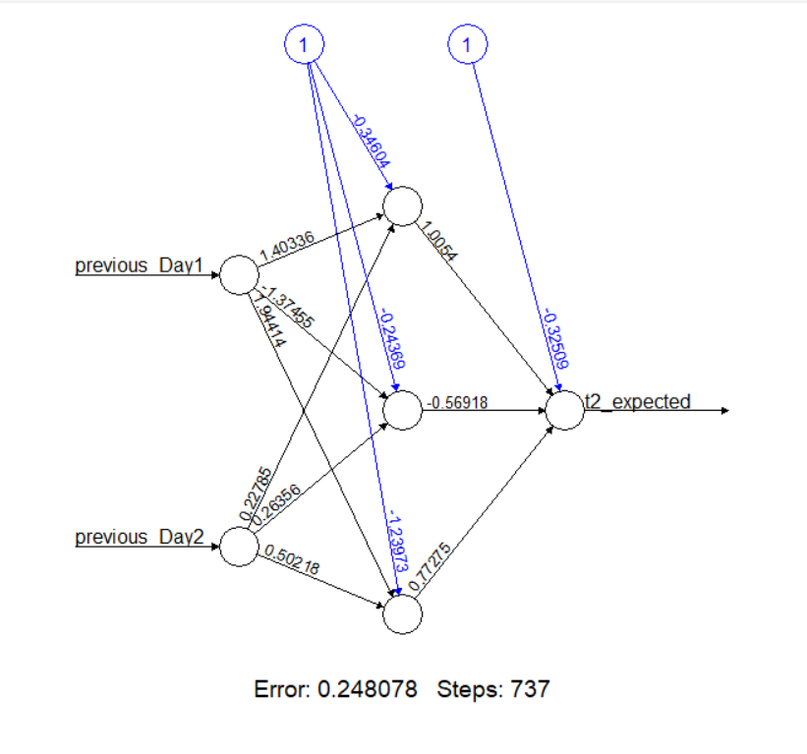

Total Number of Learnable Parameters in the Input Layer (I) =0

Total Number of Learnable Parameters in the Hidden Single Layer (H) = (2*3) + 3 = 9

Total Number of Learnable Parameters in the Output Layer (O) = (3*1) +1 = 4

Total Number of Learnable Parameters = I + H + O = 0 + 9 + 4 = 13

**The Best Double Hidden Node Layers Neural Network**

Based on our findings, the double-layer network that performed the best had 2 hidden layers with 1 and 2 nodes and utilized 2-time lagged values. In comparison to the other single-hidden layer networks, it demonstrated the lowest RMSE, MAE, MAPE, and S-MAPE values.

Total Number of Learnable Parameters in the Input Layer (I) =0

Total Number of Learnable Parameters in the Hidden Single Layer (H) = (1*2) + 2 = 4

Total Number of Learnable Parameters in the Output Layer (O) = (2*1) +1 = 3

Total Number of Learnable Parameters = I + H + O = 0 + 4 + 3 = 7

**The Best MLP Neural Network**

After analyzing various neural network configurations, it has been determined that the model with a single hidden layer containing 3 nodes and using 2-time lagged values is the most effective. This configuration exhibits lower error metrics than other single-layer networks, having a total of 13 learnable parameters. In contrast, the best-performing double hidden layer network has only 7 learnable parameters but does not reach the predictive performance of the single-layer model. These findings highlight the importance of selecting the right network architecture based on specific requirements and show that relatively simple configurations can achieve high accuracy. The single hidden layer network with 3 nodes strikes an optimal balance between complexity, performance, and computational efficiency.

|  |  |  |  |  |  |
| --- | --- | --- | --- | --- | --- |
|  | **Hidden**  **Layer Nodes** | **RMSE** | **MAE** | **MAPE** | **S-MAPE** |
| T2 | 3 | 0.005680777 | 0.004279592 | 0.3241289 | 0.3244178 |

**Appendix**

**Partitioning Clustering Part**

# Load necessary libraries

library(readxl)

library(NbClust)

library(ggplot2)

library(cluster)

library(factoextra)

# View the dataset using read_excel()

wine_data <- read_excel("Whitewine_v6.xlsx")

View(wine_data)

# Select only the first 11 attributes

wine_data <- wine_data[, 1:11]

# Z-score normalization (Standardization)

standardized_features <- scale(wine_data)

# Determine the number of clusters using NbClust

nb_clusters <- NbClust(standardized_features, distance = "euclidean", min.nc = 2, max.nc = 10, method = "complete", index = "all")

print(nb_clusters)

# Elbow method

wss <- numeric(10)

for (i in 2:10) {

tryCatch({

kmeans_model <- kmeans(standardized_features, centers = i, nstart = 25, iter.max = 100)

wss[i] <- kmeans_model$tot.withinss

}, warning = function(w) {

cat("Warning:", conditionMessage(w), "\n")

wss[i] <- NA

})

}

# Plot the elbow method

elbow_plot <- data.frame(NumClusters = 2:10, WSS = wss[2:10])

elbow <- ggplot(elbow_plot, aes(x = NumClusters, y = WSS)) +

geom_point() +

geom_line() +

labs(title = "Elbow Method", x = "Number of Clusters", y = "Within-Cluster Sum of Squares (WSS)") +

theme_minimal()

fviz_nbclust(standardized_features, kmeans, method = "wss") + labs(subtitle = "Elbow Method")

print(elbow)

# Compute gap statistics with increased number of bootstrap replicates

gap <- clusGap(standardized_features, FUN = function(x, k) kmeans(x, k, iter.max = 100), K.max = 10, B = 100)

# Plot the gap statistics

plot(gap, main = "Gap statistic for k-means clustering")

# Determine the optimal number of clusters using maxSE function

best_clusters <- maxSE(gap$Tab[, "gap"], gap$Tab[, "SE.sim"], method = "Tibs2001SEmax")

# Check contents of best_clusters list

str(best_clusters)

# Silhouette method

# Compute silhouette scores

silhouette <- sapply(2:10, function(k) {

kmeans_model <- kmeans(standardized_features, centers = k, nstart = 25, iter.max = 100) # Increase iter.max

silhouette_avg <- silhouette(kmeans_model$cluster, dist(standardized_features))

mean(silhouette_avg[, "sil_width"])

})

# Plot silhouette scores

silhouette_plot <- ggplot(data.frame(K = 2:10, Silhouette = silhouette), aes(x = K, y = Silhouette)) +

geom_line() +

geom_point() +

labs(title = "Silhouette Method", x = "Number of Clusters", y = "Silhouette Score") +

theme_minimal()

print(silhouette_plot)

# PCA analysis

pca_result <- prcomp(standardized_features, center = TRUE)

print(summary(pca_result))

# Print eigenvalues and eigenvectors

print(pca_result$sdev) #this print the eigenvalues

print(pca_result$rotation)#this prints the eigenvectors

# Create a plot of the explained variance by each principal component

fviz_eig(pca_result)

# Create a plot of the cumulative variance explained by each principal component

fviz_eig(pca_result, choice = "variance")

# Create a plot of the correlation between variables and principal components

fviz_pca_var(pca_result)

# Calculate cumulative variance explained by each principal component

cumulative_variance <- cumsum(pca_result$sdev^2 / sum(pca_result$sdev^2))

# Find the number of principal components required to achieve cumulative score > 0.85

pc_cutoff <- min(which(cumulative_variance > 0.85))

# Select principal components

selected_pcs <- paste0("PC", 1:pc_cutoff)

# Create a transformed dataset with only the selected principal components as attributes

transformed_dataset <- predict(pca_result, standardized_features)[, 1:pc_cutoff]

colnames(transformed_dataset) <- selected_pcs

# Print selected PCs

print(selected_pcs)

# Print transformed dataset with selected PCs

head(transformed_dataset)

# Determine the number of clusters using NbClust

nb_clusters <- NbClust(transformed_dataset, distance = "euclidean", min.nc = 2, max.nc = 10, method = "complete", index = "all")

print(nb_clusters)

# Elbow method

wss <- numeric(10)

for (i in 2:10) {

tryCatch({

kmeans_model <- kmeans(transformed_dataset, centers = i, nstart = 25, iter.max = 100)

wss[i] <- kmeans_model$tot.withinss

}, warning = function(w) {

cat("Warning:", conditionMessage(w), "\n")

wss[i] <- NA

})

}

# Plot the elbow method

elbow_plot <- data.frame(NumClusters = 2:10, WSS = wss[2:10])

elbow <- ggplot(elbow_plot, aes(x = NumClusters, y = WSS)) +

geom_point() +

geom_line() +

labs(title = "Elbow Method", x = "Number of Clusters", y = "Within-Cluster Sum of Squares (WSS)") +

theme_minimal()

print(elbow)

# Compute gap statistics with increased number of bootstrap replicates

gap <- clusGap(transformed_dataset, FUN = function(x, k) kmeans(x, k, iter.max = 100), K.max = 10, B = 100)

# Plot the gap statistics

plot(gap, main = "Gap statistic for k-means clustering")

# Determine the optimal number of clusters using maxSE function

best_clusters <- maxSE(gap$Tab[, "gap"], gap$Tab[, "SE.sim"], method = "Tibs2001SEmax")

# Check contents of best_clusters list

str(best_clusters)

# Silhouette Plot

fviz_nbclust(transformed_dataset, kmeans, method = 'silhouette')

# Add k=2

k <- 2

set.seed(123) # Set the seed for reproducibility

km <- kmeans(transformed_dataset, centers = k, nstart = 25)

fviz_cluster(km, data = transformed_dataset)

print(km)

print(km$centers)

# Display the BSS/TSS ratio

BSS <- sum(km$betweenss)

WSS<-sum(km$tot.withinss)

TSS <- sum(km$totss)

BSS_TSS_ratio <- BSS/TSS

WSS_TSS_ratio <- WSS/TSS

cat("The ratio of between_cluster_sums_of_squares (BSS) over

total_sum_of_squares (TSS) is", BSS_TSS_ratio, "\n")

cat("The ratio of within_cluster_sums_of_squares WSS) over

total_sum_of_squares (TSS) is", WSS_TSS_ratio, "\n")

# Display the BSS and WSS indices

cat("The between_cluster_sums_of_squares (BSS) index is", BSS, "\n")

cat("The within_cluster_sums_of_squares (WSS) index is", WSS, "\n")

# Add k=3

k <- 3

set.seed(123) # Set the seed for reproducibility

km <- kmeans(transformed_dataset, centers = k, nstart = 25)

fviz_cluster(km, data =transformed_dataset)

print(km)

print(km$centers)

# Display the BSS/TSS ratio

BSS <- sum(km$betweenss)

WSS<-sum(km$tot.withinss)

TSS <- sum(km$totss)

BSS_TSS_ratio <- BSS/TSS

WSS_TSS_ratio <- WSS/TSS

cat("The ratio of between_cluster_sums_of_squares (BSS) over

total_sum_of_squares (TSS) is", BSS_TSS_ratio, "\n")

cat("The ratio of within_cluster_sums_of_squares WSS) over

total_sum_of_squares (TSS) is", WSS_TSS_ratio, "\n")

# Display the BSS and WSS indices

cat("The between_cluster_sums_of_squares (BSS) index is", BSS, "\n")

cat("The within_cluster_sums_of_squares (WSS) index is", WSS, "\n")

# Add k= 8

k <- 8

set.seed(123) # Set the seed for reproducibility

km <- kmeans(transformed_dataset, centers = k, nstart = 25)

fviz_cluster(km, data = transformed_dataset)

print(km)

print(km$centers)

# Display the BSS/TSS ratio

BSS <- sum(km$betweenss)

WSS<-sum(km$tot.withinss)

TSS <- sum(km$totss)

BSS_TSS_ratio <- BSS/TSS

WSS_TSS_ratio <- WSS/TSS

cat("The ratio of between_cluster_sums_of_squares (BSS) over

total_sum_of_squares (TSS) is", BSS_TSS_ratio, "\n")

cat("The ratio of within_cluster_sums_of_squares WSS) over

total_sum_of_squares (TSS) is", WSS_TSS_ratio, "\n")

# Display the BSS and WSS indices

cat("The between_cluster_sums_of_squares (BSS) index is", BSS, "\n")

cat("The within_cluster_sums_of_squares (WSS) index is", WSS, "\n")

# Display the silhouette plot

# Compute silhouette values

sil <- silhouette(km$cluster, dist(transformed_dataset))

# Plot the silhouette

fviz_silhouette(sil)

# Calculate average silhouette width

average_silhouette_width <- mean(sil[, "sil_width"])

cat("Average silhouette width:", average_silhouette_width)

library(fpc) # Load the fpc package

# Calculate the Calinski-Harabasz index for 2-10 clusters

res <- NbClust(transformed_dataset, diss = NULL, distance = "euclidean", min.nc = 2, max.nc = 10, method = "kmeans", index = "ch")

print(res)

print(res$Best.nc)

# Plot the results

barplot(res$Best.nc[2], names.arg = res$Best.nc[1], xlab = "Number of clusters", ylab ="Calinski-Harabasz index")

**Financial Forecasting Part (AR Approach)**

# Load libraries

library("readxl")

library("dplyr")

library("ggplot2")

library("reshape2")

library("gridExtra")

library("neuralnet")

library("grid")

library("MASS")

library("MLmetrics")

# Import the dataset using the read_excel() function

data <- read_excel("ExchangeUSD.xlsx")

head(dataset)

dim(dataset)

# Take only the exchange rate column

dataset <- as.data.frame(data[[3]])

head(dataset)

# Data Preparation

#Function used to normalize using the Min-max normalization method

normalize <- function(x) {

return((x - min(x)) / (max(x) - min(x)))

}

#Function used to de-normalize(Min-max normalization)

unnormalize <- function(x, min, max) {

return( (max - min)*x + min )

}

# Normalizing the dataset

datast_norm <- as.data.frame(lapply(dataset, normalize))

head(datast_norm)

# Splitting the normalized data into training and testing sets

data_train <- datast_norm[1:400, ]

data_test <- datast_norm[401:500, ]

# Creating lagged features for 1 lag

t1_train <- bind_cols(previous_Day1 = lag(data_train, 1),

t1_expected = data_train)

t1_test <- bind_cols(previous_Day1 = lag(data_test, 1),

t1_expected = data_test)

# Removing rows with missing values

t1_train <- t1_train[complete.cases(t1_train), ]

t1_test <- t1_test[complete.cases(t1_test), ]

# Displaying the first few rows of the training dataset with lagged features (1 lag)

head(t1_train)

# Displaying the first few rows of the testing dataset with lagged features (1 lag)

head(t1_test)

# Creating lagged features for 2 lag

t2_train <- bind_cols(previous_Day2 = lag(data_train, 2),

previous_Day1 = lag(data_train, 1),

t2_expected = data_train)

t2_test <- bind_cols(previous_Day2 = lag(data_test, 2),

previous_Day1 = lag(data_test, 1),

t2_expected = data_test)

# Removing rows with missing values

t2_train <- t2_train[complete.cases(t2_train), ]

t2_test <- t2_test[complete.cases(t2_test), ]

# Displaying the first few rows of the training dataset with lagged features (2 lags)

head(t2_train)

# Displaying the first few rows of the testing dataset with lagged features (2 lags)

head(t2_test)

# Creating lagged features for 3 lags in the training dataset

t3_train <- bind_cols(previous_Day3 = lag(data_train, 3),

previous_Day2 = lag(data_train, 2),

previous_Day1 = lag(data_train, 1),

t3_expected = data_train)

# Creating lagged features for 3 lags in the testing dataset

t3_test <- bind_cols(previous_Day3 = lag(data_test, 3),

previous_Day2 = lag(data_test, 2),

previous_Day1 = lag(data_test, 1),

t3expected = data_test)

# Removing rows with missing values

t3_train <- t3_train[complete.cases(t3_train), ]

t3_test <- t3_test[complete.cases(t3_test), ]

# Displaying the first few rows of the training dataset with lagged features (3 lags)

head(t3_train)

# Displaying the first few rows of the testing dataset with lagged features (3 lags)

head(t3_test)

# For 1 lagged value

modelt1 <- neuralnet(t1_expected ~ previous_Day1, hidden = c(2, 3),

data = t1_train, linear.output = TRUE)

# Plotting the neural network model for the 1 lag time horizon

plot(modelt1)

# Displaying the result matrix of the trained neural network model

modelt1$result.matrix

# Making predictions on the test set using the trained model

resultt1 <- compute(modelt1, t1_test[1])

# Extracting normalized predictions from the neural network output

norm_predictiont1 <- resultt1$net.result

# Denormalizing the normalized predictions to obtain actual values

denorm_predictiont1 <- unnormalize(norm_predictiont1, min(dataset), max(dataset))

denorm_predictiont1 <- round(denorm_predictiont1, 4)

# Denormalizing the test set to obtain actual values

denorm_resultt1 <- unnormalize(t1_test, min(dataset), max(dataset))

denorm_resultt1 <- round(denorm_resultt1, 4)

# Creating a summary table of expected and predicted values

summaryt1 <- cbind(denorm_resultt1[2], denorm_predictiont1)

colnames(summaryt1) <- c("Expected_T1", "Prediction1")

# Displaying the summary table

summaryt1

# Evaluation metrics for t1 lagged values

rmse_t1 <- sqrt(mean((summaryt1$Expected_T1 - summaryt1$Prediction1)^2))

mae_t1 <- mean(abs(summaryt1$Expected_T1 - summaryt1$Prediction1))

mape_t1 <- mean(abs((summaryt1$Expected_T1 - summaryt1$Prediction1) / summaryt1$Expected_T1)) * 100

smape_t1 <- mean(2 * abs(summaryt1$Expected_T1 - summaryt1$Prediction1) / (abs(summaryt1$Expected_T1) + abs(summaryt1$Prediction1))) * 100

# Print evaluation metrics for t1 lagged values

cat("RMSE:", rmse_t1, "\n")

cat("MAE:", mae_t1, "\n")

cat("MAPE:", mape_t1, "\n")

cat("s-MAPE:", smape_t1, "\n")

# For 2 lagged values

modelt2 <- neuralnet(t2_expected ~ previous_Day1 + previous_Day2, hidden = 2,

data = t2_train, linear.output = TRUE)

# Plotting the neural network model for the 2 lag time horizon

plot(modelt2)

# Displaying the result matrix of the trained neural network model for 2 lags

modelt2$result.matrix

# Making predictions on the test set using the trained model for 2 lags

resultt2 <- compute(modelt2, t2_test[1:2])

# Extracting normalized predictions from the neural network output

norm_predictiont2 <- resultt2$net.result

# Denormalizing the normalized predictions to obtain actual values

denorm_predictiont2 <- unnormalize(norm_predictiont2, min(dataset), max(dataset))

denorm_predictiont2 <- round(denorm_predictiont2, 4)

# Denormalizing the test set to obtain actual values

denorm_resultt2 <- unnormalize(t2_test, min(dataset), max(dataset))

denorm_resultt2 <- round(denorm_resultt2, 4)

# Creating a summary table of expected and predicted values for 2 lags

summaryt2 <- cbind(denorm_resultt2[2], denorm_predictiont2)

colnames(summaryt2) <- c("Expected_T2", "Prediction2")

# Displaying the summary table for 2 lags

summaryt2

# Evaluation metrics for t2 lagged values

rmse_t2 <- sqrt(mean((summaryt2$Expected_T2 - summaryt2$Prediction2)^2))

mae_t2 <- mean(abs(summaryt2$Expected_T2 - summaryt2$Prediction2))

mape_t2 <- mean(abs((summaryt2$Expected_T2 - summaryt2$Prediction2) / summaryt2$Expected_T2)) * 100

smape_t2 <- mean(2 * abs(summaryt2$Expected_T2 - summaryt2$Prediction2) / (abs(summaryt2$Expected_T2) + abs(summaryt2$Prediction2))) * 100

# Print evaluation metrics for t2 lagged values

cat("RMSE:", rmse_t2, "\n")

cat("MAE:", mae_t2, "\n")

cat("MAPE:", mape_t2, "\n")

cat("s-MAPE:", smape_t2, "\n")

# For 3 lagged values

modelt3 <- neuralnet(t3_expected ~ previous_Day1 + previous_Day2 + previous_Day3, hidden = c(4, 5),

data = t3_train, linear.output = TRUE)

# Plotting the neural network model for the 3 lag time horizon

plot(modelt3)

# Displaying the result matrix of the trained neural network model for 3 lags

modelt3$result.matrix

# Making predictions on the test set using the trained model for 3 lags

resultt3 <- compute(modelt3, t3_test[1:3])

# Extracting normalized predictions from the neural network output

norm_predictiont3 <- resultt3$net.result

# Denormalizing the normalized predictions to obtain actual values

denorm_predictiont3 <- unnormalize(norm_predictiont3, min(dataset), max(dataset))

denorm_predictiont3 <- round(denorm_predictiont3, 4)

# Denormalizing the test set to obtain actual values

denorm_resultt3 <- unnormalize(t3_test, min(dataset), max(dataset))

denorm_resultt3 <- round(denorm_resultt3, 4)

# Creating a summary table of expected and predicted values for 3 lags

summaryt3 <- cbind(denorm_resultt3[2], denorm_predictiont3)

colnames(summaryt3) <- c("Expected_T3", "Prediction3")

# Displaying the summary table for 3 lags

summaryt3

# Evaluation metrics for t3 lagged values

rmse_t3 <- sqrt(mean((summaryt3$Expected_T3 - summaryt3$Prediction3)^2))

mae_t3 <- mean(abs(summaryt3$Expected_T3 - summaryt3$Prediction3))

mape_t3 <- mean(abs((summaryt3$Expected_T3 - summaryt3$Prediction3) / summaryt3$Expected_T3)) * 100

smape_t3 <- mean(2 * abs(summaryt3$Expected_T3 - summaryt3$Prediction3) / (abs(summaryt3$Expected_T3) + abs(summaryt3$Prediction3))) * 100

# Print evaluation metrics for t3 lagged values

cat("RMSE:", rmse_t3, "\n")

cat("MAE:", mae_t3, "\n")

cat("MAPE:", mape_t3, "\n")

cat("s-MAPE:", smape_t3, "\n")

# Scatter Plot of predicted vs. expected values

par(mfrow = c(1, 1))

plot(summaryt2$Expected_T2, summaryt2$Prediction2, col = 'red', main = 'Real vs predicted NN', pch = 18, cex = 0.7, xlab = "Expected", ylab = "Predicted")

abline(a = 0, b = 1, h = 90, v = 90)

# Line chart of predicted vs. expected values

x <- 1:length(summaryt2$Expected_T2)

plot(x, summaryt2$Expected_T2, col = "red", type = "l", lwd = 2,

main = "exchange rate prediction")

lines(x, summaryt2$Prediction2, col = "blue", lwd = 2)

legend("topleft", legend = c("original-rate", "predicted-rate"),

fill = c("red", "blue"), col = 2:3, adj = c(0, 0.6))

grid()

**References**

1. Brownlee, J. (2020) How to Develop Multilayer Perceptron Models for Time Series Forecasting. Available at: https://machinelearningmastery.com/how-to-develop-multilayer-perceptron-models-for-time-series-forecasting/ (Accessed: 05 May 2024).
2. Statistical Point. (No date) MAE vs RMSE. Available at: https://statisticalpoint.com/mae-vs-rmse/ (Accessed: 06 May 2024).
3. Towards Data Science. (2019) Forecast KPI: RMSE, MAE, MAPE, Bias. Available at: https://towardsdatascience.com/forecast-kpi-rmse-mae-mape-bias-cdc5703d242d (Accessed: 06 May 2024).
4. Sefidian. (2022) A Guide on Regression Error Metrics with Python Code. Available at: https://sefidian.com/2022/08/18/a-guide-on-regression-error-metrics-with-python-code/ (Accessed: 06 May 2024).
5. Vandeput, N. (2019) Forecast KPI: RMSE, MAE, MAPE & Bias. Available at: https://towardsdatascience.com/forecast-kpi-rmse-mae-mape-bias-cdc5703d242d (Accessed: 09 May 2024).